**Lab 08 -- Utilizing prompt engineering to enhance model responses**

**Introduction**

GPT-3, GPT-3.5, and GPT-4 models from OpenAI are prompt-based. With prompt-based models, the user interacts with the model by entering a text prompt, to which the model responds with a text completion. This completion is the model's continuation of the input text. While these models are extremely powerful, their behavior is also very sensitive to the prompt. This makes prompt construction an important skill to develop.

With the Azure OpenAI Service, developers can create chatbots, language models, and other applications that excel at understanding natural human language. The Azure OpenAI provides access to pre-trained AI models, as well as a suite of APIs and tools for customizing and fine-tuning these models to meet the specific requirements of your application.

When working with the Azure OpenAI Service, how developers shape their prompt greatly impacts how the generative AI model will respond. Azure OpenAI models are able to tailor and format content, if requested in a clear and concise way.

Imagine you are trying to send out information for a new wildlife rescue, and want to get assistance from a generative AI model. In this lab, you'll learn how to deploy a model in Azure OpenAI and use it in your own application to summarize text.

**Objectives**

* To deploy gpt-35 turbo model and examine how prompt engineering improves the model response in the Azure AI Studio Chat playground.
* To setup, configure, and run your application in Cloud Shell to know how different prompts for similar content help shape the AI model's response to better satisfy your requirements.

**Prerequisites**

* Before starting this lab, kindly complete the Lab 01- Provisioning Azure OpenAI resource.

**Task 1: Deploy gpt-35-turbo model**

To use the Azure OpenAI API, you must first deploy a model to use through the **Azure OpenAI Studio**. Once deployed, we will reference that model in our app.

1. Open your browser, navigate to the address bar, and type or paste the following URL: **https://oai.azure.com/** then press the Enter button.

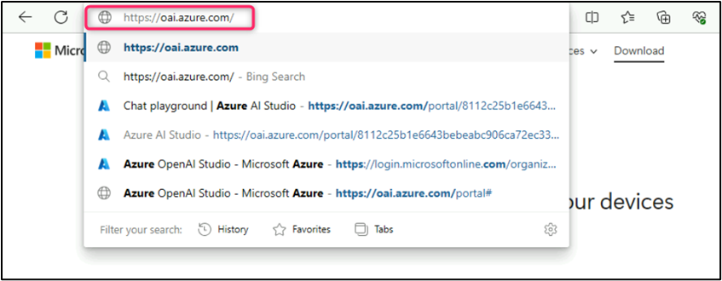

**Note:** If you are directed to the Azure OpenAI Studio home page, then skip steps from #2 to #4, else continue.

1. In the **Microsoft Azure** window, enter your **Sign-in** credentials, and click on the **Next** button.

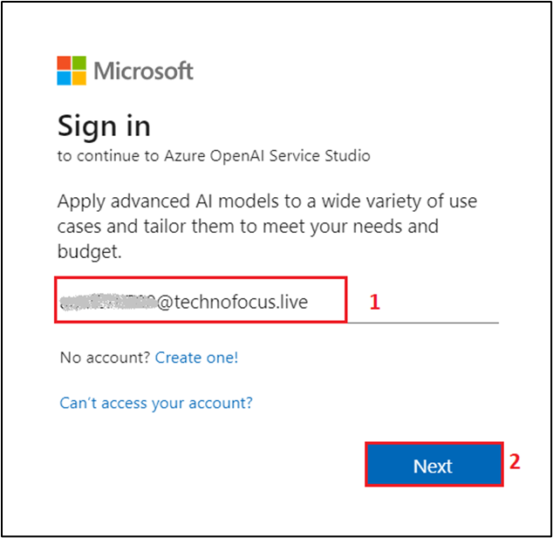

1. Then, enter the password and click on the Sign in button.

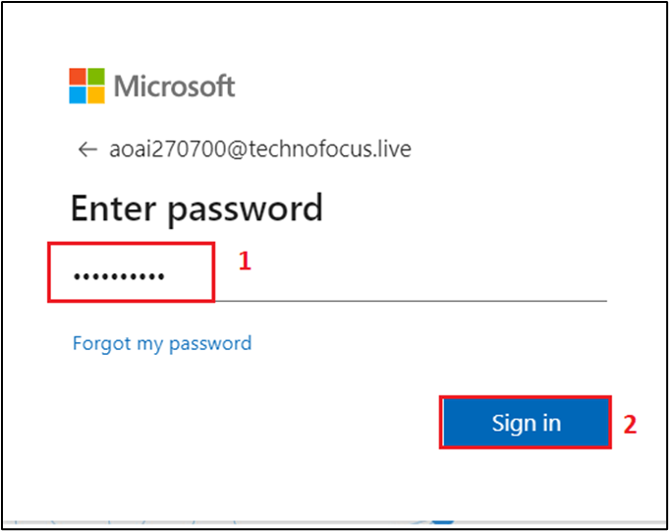

1. In **Stay signed in?** window, click on the **Yes** button.

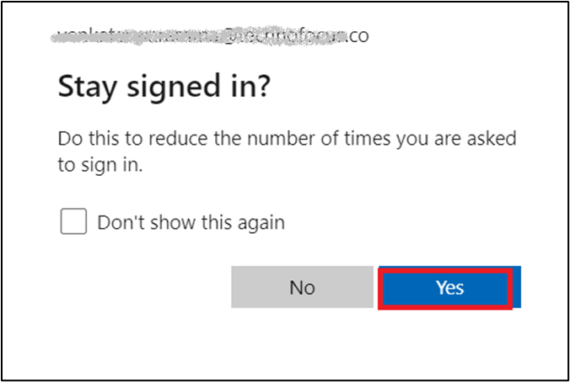

1. On the **Welcome to Azure OpenAI Studio** dialog box, under the **Subscription** field, enter the subscription assigned to you, and in the **Resource** field, select the Resource name that you’ve created in Lab #1, and then click on the **Use resource** button.

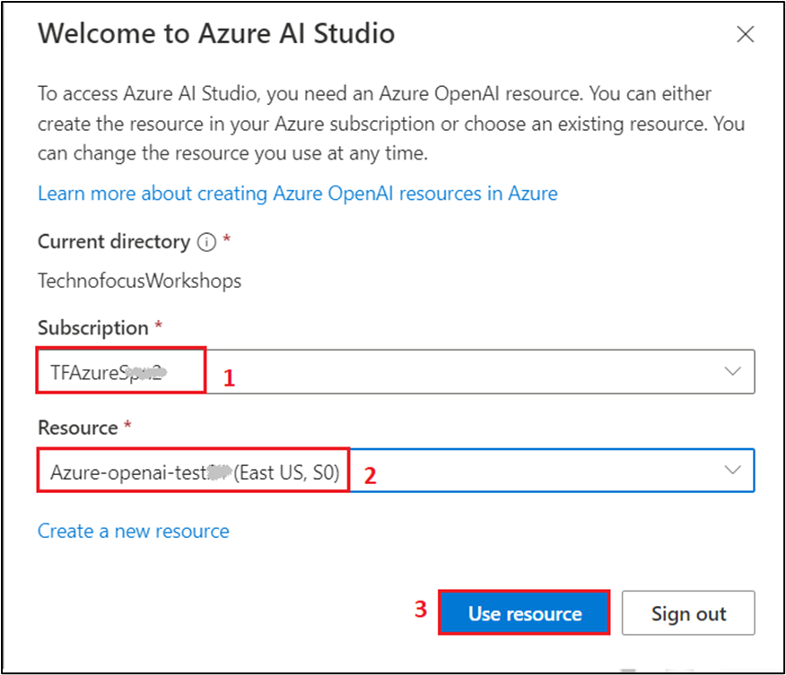

1. Wait for the Azure OpenAI studio to launch.

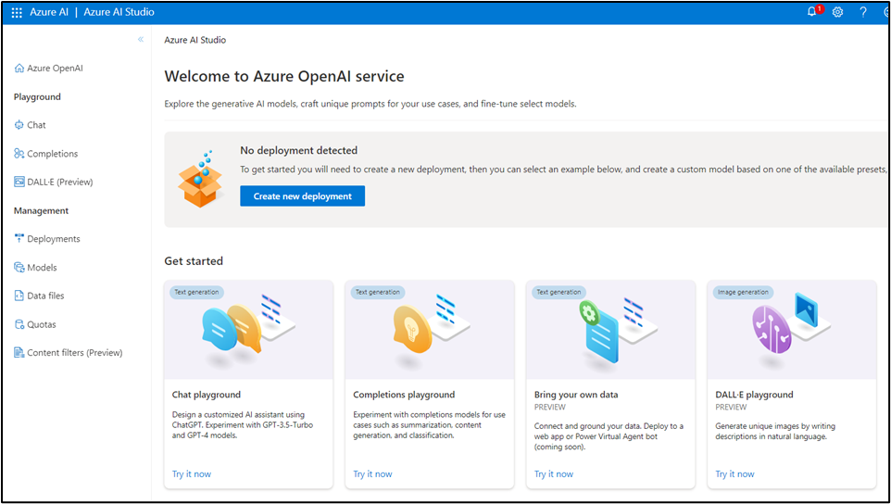

1. On the **Azure OpenAI Studio** homepage, click on **Create new deployment** button.

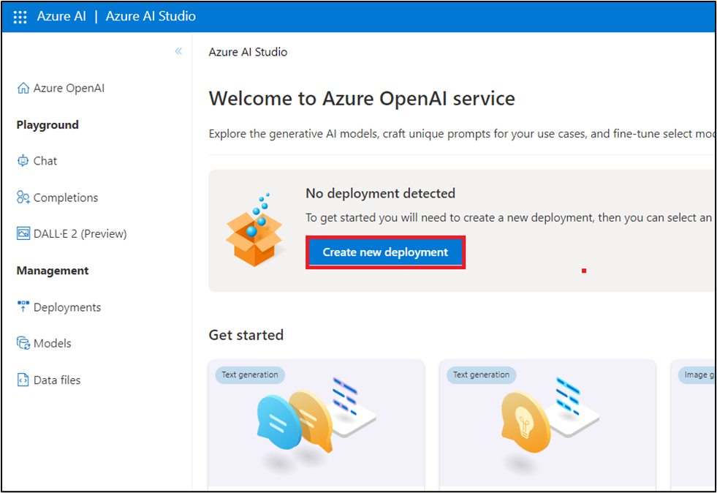

1. In the **Deployments** page, click on +**Create new deployment**.

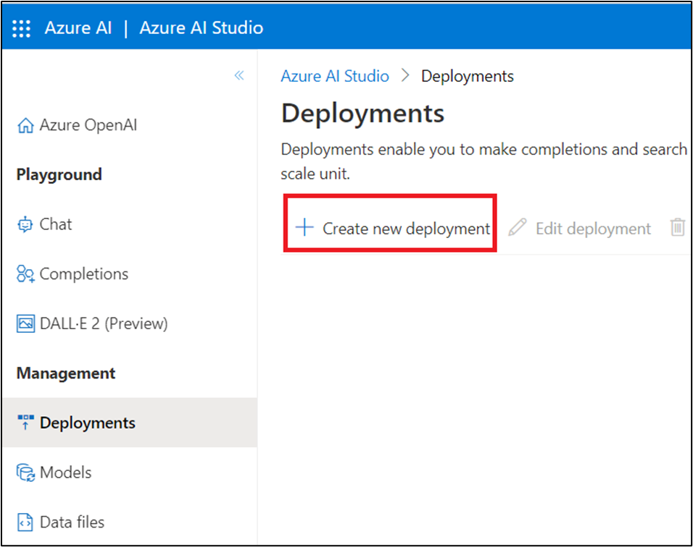

1. In the **Deploy model dialog** box, under the **Model name** field, click on the V chevron button; navigate and select carefully **gpt-35-turbo**.

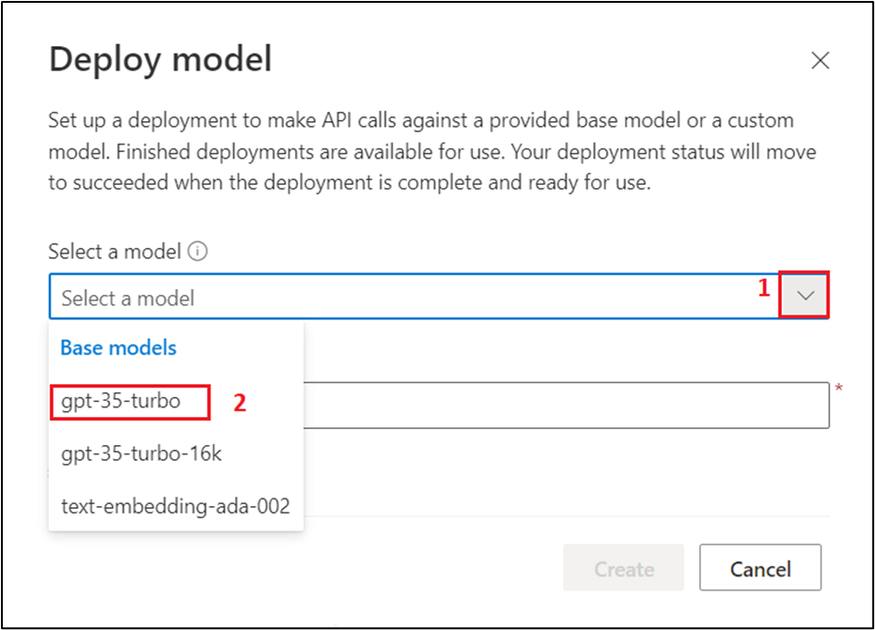

1. Select the **Model version** as **Auto-update to default**, in the **Deployment name field**, enter **text-turbo**, and click on the **Create** button.

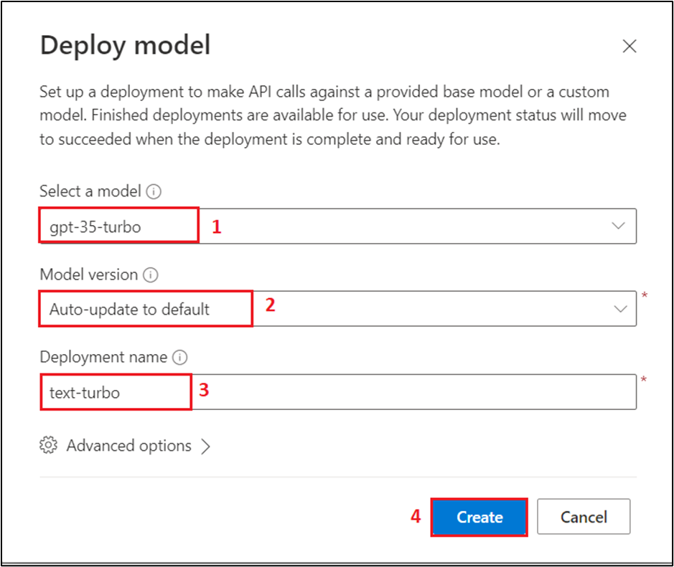

**Note**: Azure OpenAI includes multiple models, each optimized for a different balance of capabilities and performance. In this exercise, you’ll use the **GPT-35-Turbo** model, which is a good general model for summarizing and generating natural language and code. For more information about the available models in Azure OpenAI, see Models in the Azure OpenAI documentation.

1. You will see a notification – **Successfully Created deployment** when the deployment is succeeded. (You can also view the notification by clicking on the bell icon beside **Azure AI | Azure AI Studio**).

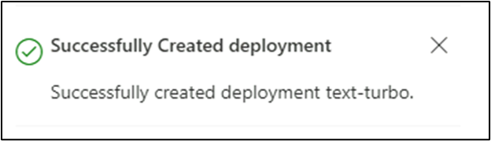

**Task 2: Apply prompt engineering in Chat playground**

Before using app, examine how prompt engineering improves the model response in the playground. In this first example, we are trying to write a python app of animals with fun names.

1. In Azure OpenAI Studio, navigate and click on **Chat** under the **Playground** section in the left pane.

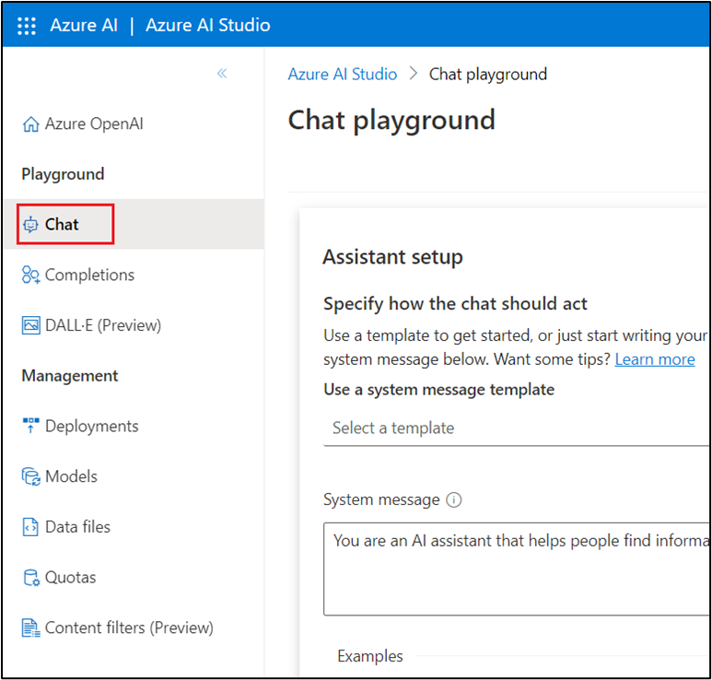

1. On the **Chat playground** page, under **Assistant setup** section, in the System message textbox, enter **You are a helpful AI assistant**.

**Note:** You can use Ctrl+- or Ctrl+minus keyboard shortcut to zoom out and decrease the font size, so that Chat session pane appear on the right side.

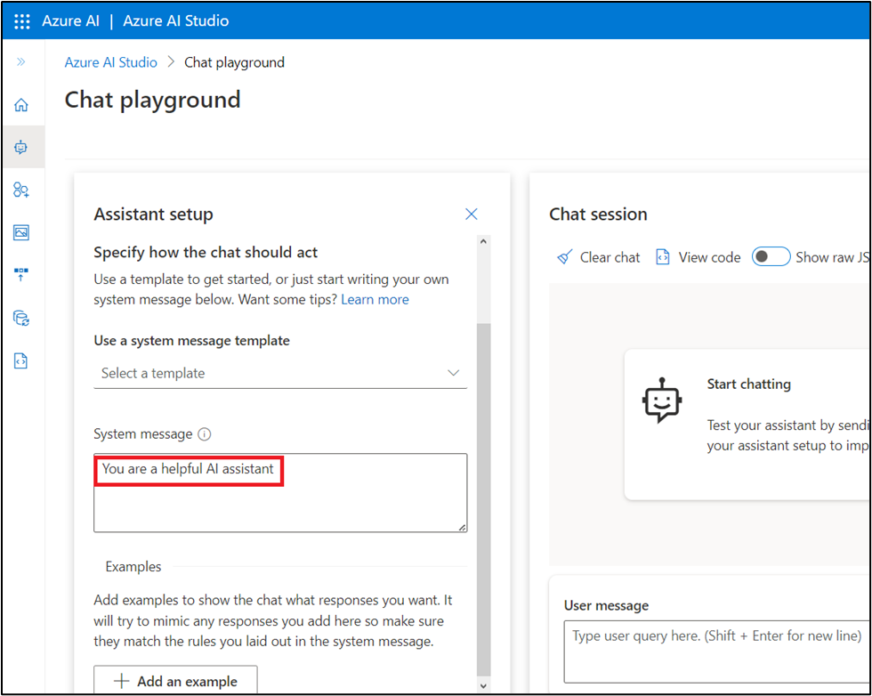

1. In the **Chat session** section, enter the following prompt in the **User message** text box and click on the **Send** icon.

**python**

1. Create a list of animals

2. Create a list of whimsical names for those animals

3. Combine them randomly into a list of 25 animal and name pairs

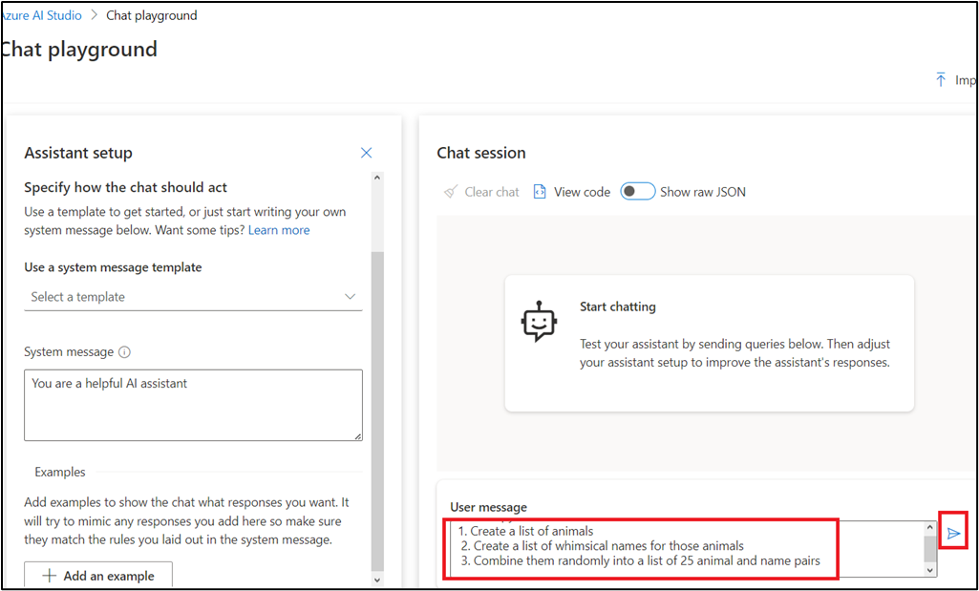

1. The model will likely respond with an answer to satisfy the prompt, split into a numbered list. This is a good response, but not what we're looking for.

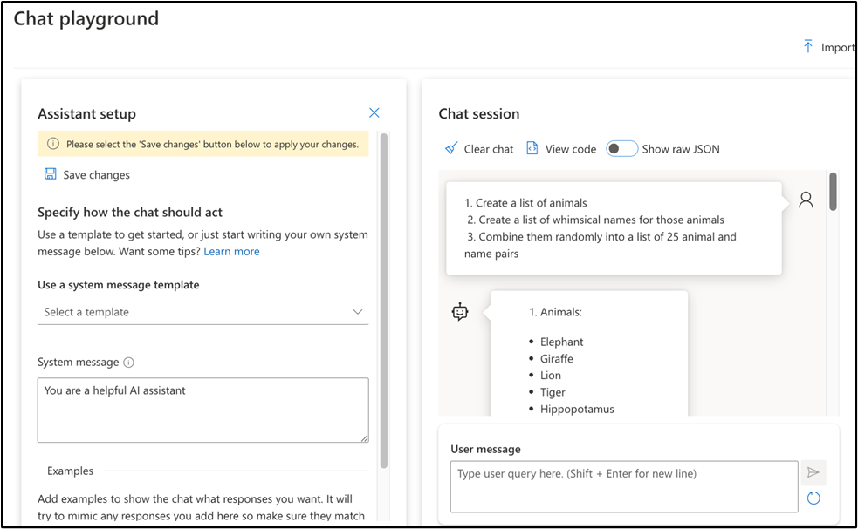

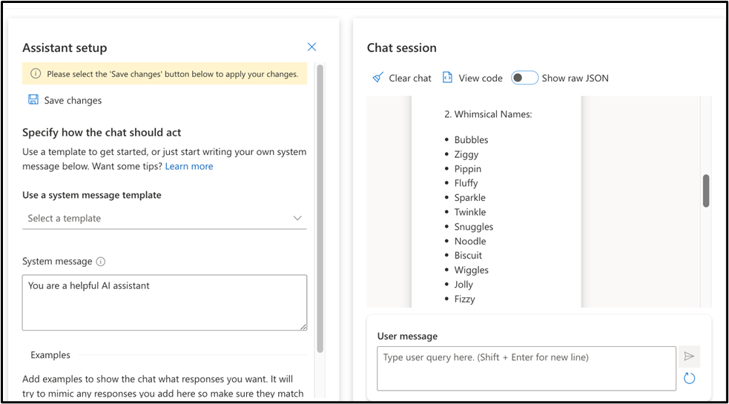

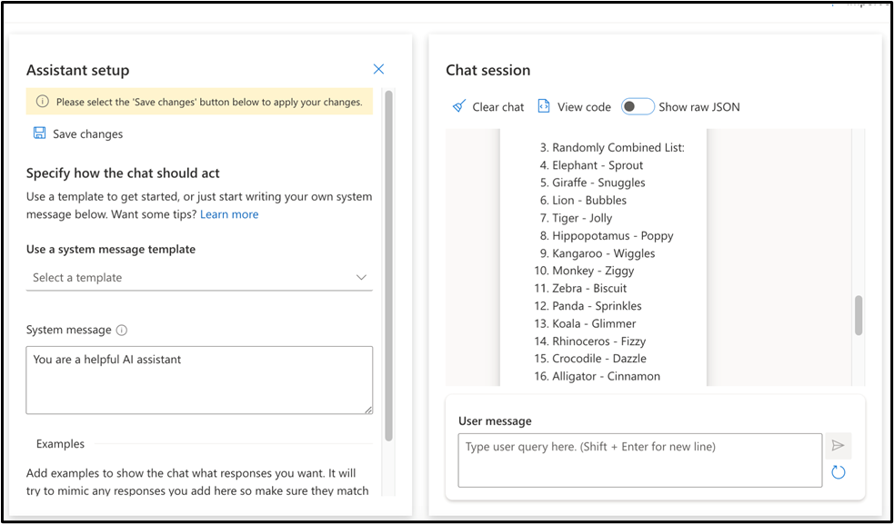

1. In the **System message** text box, replace the previous text with the following text to include instructions **You are an AI assistant helping write python code. Complete the app based on provided comments.** Then, click on **Apply changes**.

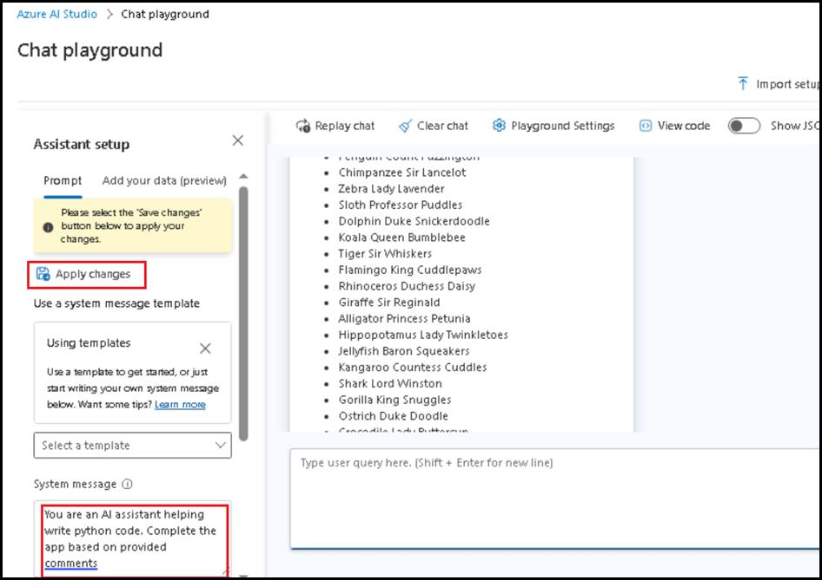

1. In the **Update system message?** dialog box, click on the **Continue button.**

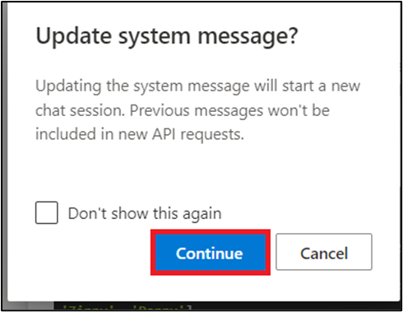

1. Format the instructions as python comments. Send the following prompt to the model by pasting them in **User message** text box and clicking on the **Send** icon.

**python**

# 1. Create a list of animals

# 2. Create a list of whimsical names for those animals

# 3. Combine them randomly into a list of 25 animal and name pairs

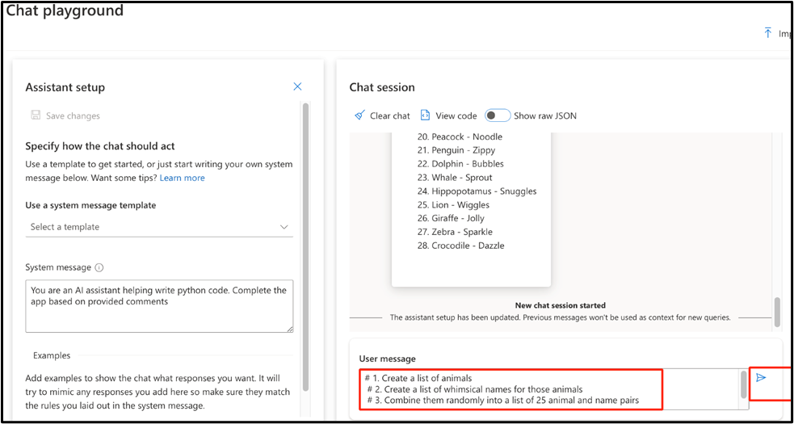

1. The model will respond with complete python code that can accomplish the instructions provided through the python comments.

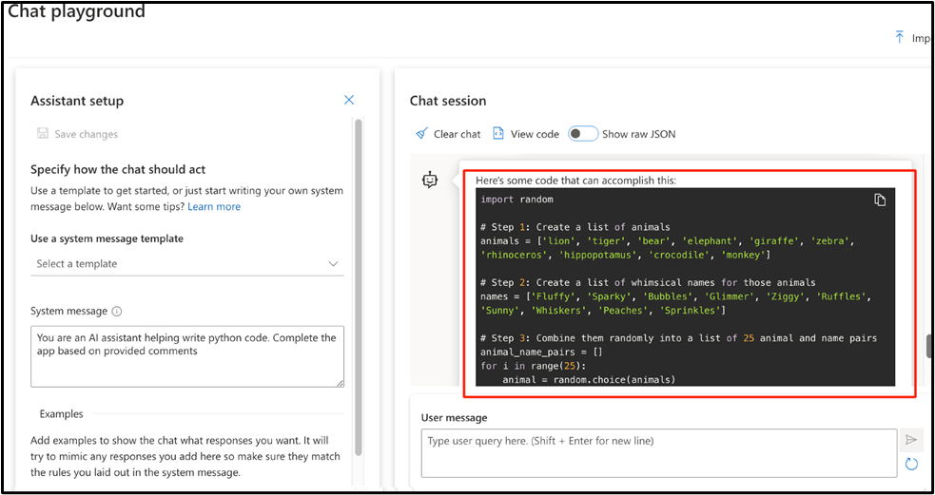

1. Next, you'll see the impact of few shots prompting when attempting to classify articles. Go back to the **System message** text box, select and delete the previous text and enter **You are a helpful AI assistant** again, and click on **Apply changes**. This will create a new chat session.

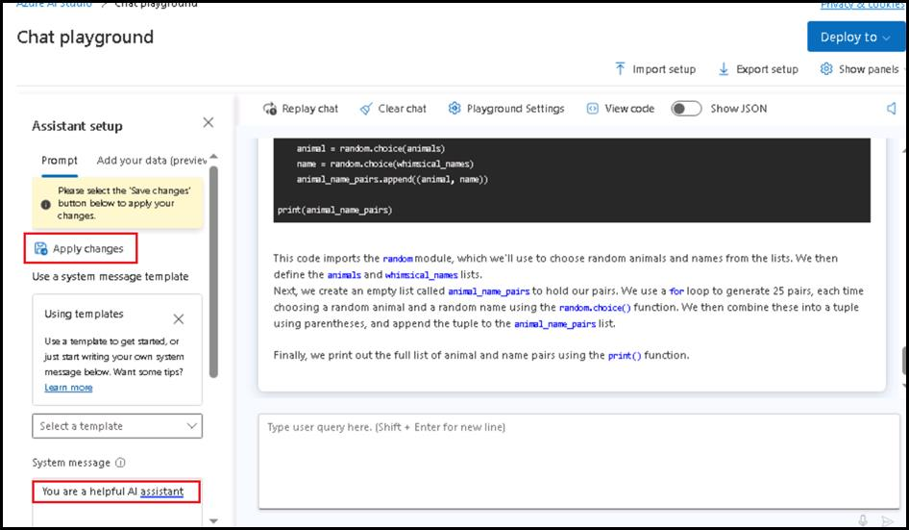

1. In the **Update system message?** dialog box, click on the **Continue button.**



1. In the **User message** text box, enter the following text and click on the **Send** icon.
2. Severe drought likely in California
3. Millions of California residents are bracing for less water and dry lawns as drought threatens to leave a large swath of the region with a growing water shortage.
4. In a remarkable indication of drought severity, officials in Southern California have declared a first-of-its-kind action limiting outdoor water use to one day a week for nearly 8 million residents.

Much remains to be determined about how daily life will change as people adjust to a drier normal. But officials are warning the situation is dire and could lead to even more severe limits later in the year.

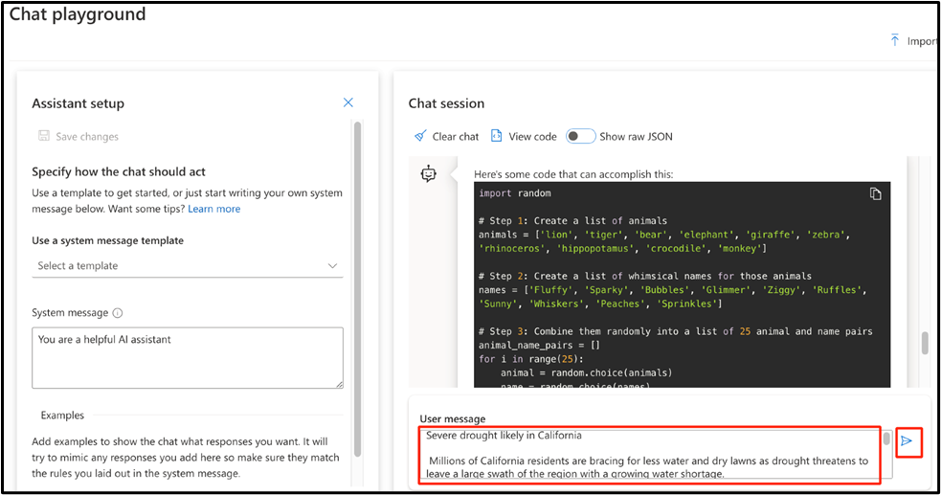

1. The response will likely be some information about drought in California. While not a bad response, it's not the classification we're looking for.

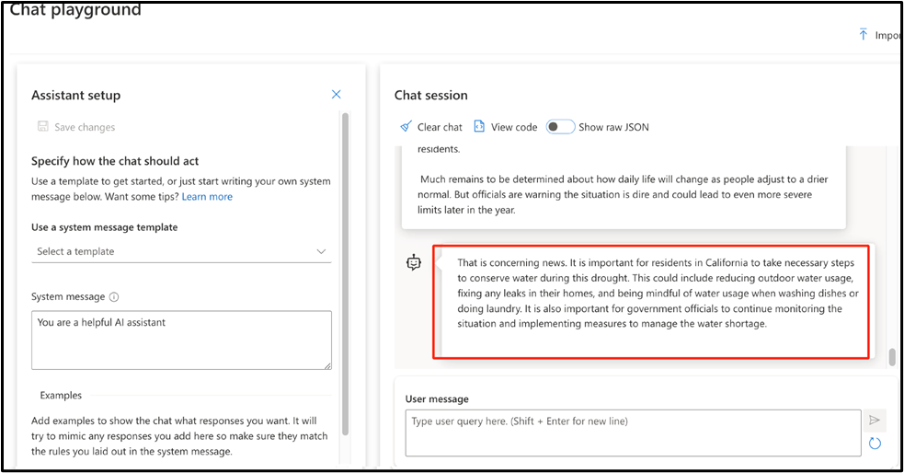

**Note**: You may receive a similar or different response from the model.

1. In the **Assistant setup** section, below the **System message** text box, click on +**Add** button. Then, add the following text in **User** and **Assistant** text boxes as shown in the below image.

**User:**

New York Baseballers Wins Big Against Chicago

New York Baseballers mounted a big 5-0 shutout against the Chicago

Cyclones last night, solidifying their win with a 3 run homerun late

in the bottom of the 7th inning.

Pitcher Mario Rogers threw 96 pitches with only two hits for New York,

marking his best performance this year.

The Chicago Cyclones' two hits came in the 2nd and the 5th innings,

but were unable to get the runner home to score.

**Assistant:**

Sports

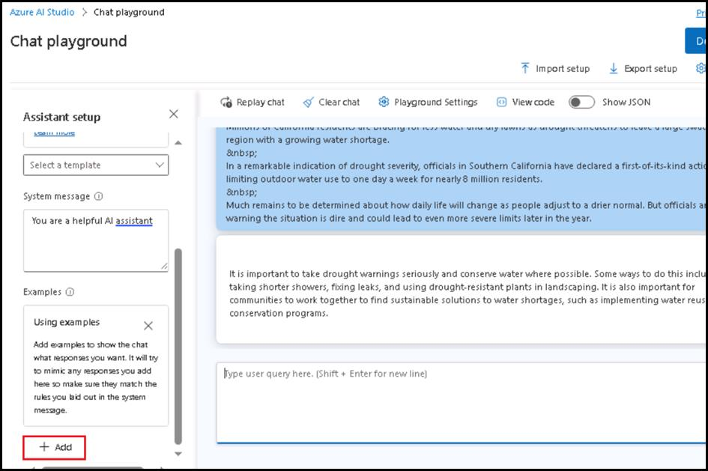

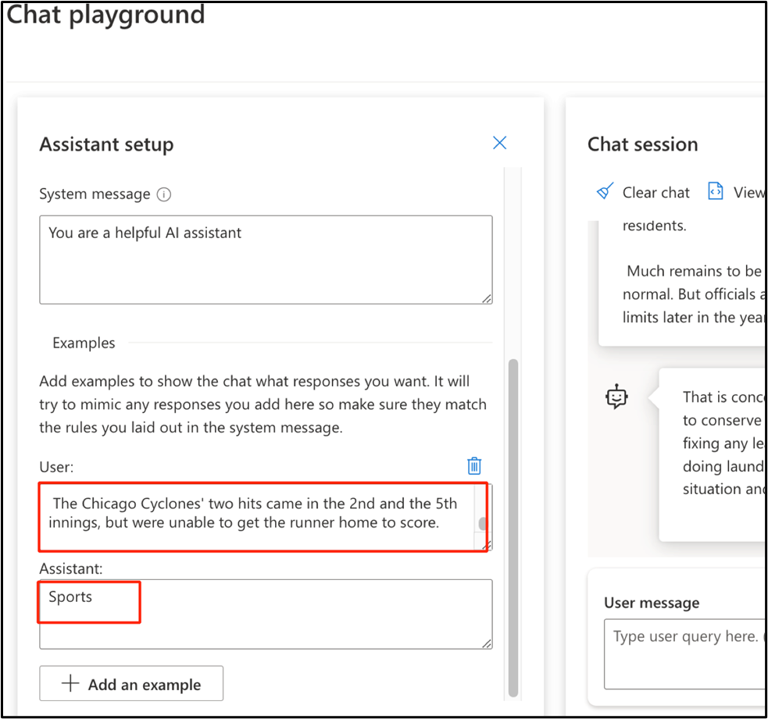

1. Click again on **+Add** button to add another example. Then, add the following text in **User** and **Assistant** text boxes as shown in the below image:

**User:**

Joyous moments at the Oscars

The Oscars this past week where quite something!

Though a certain scandal might have stolen the show, this year's

Academy Awards were full of moments that filled us with joy and even

moved us to tears.

These actors and actresses delivered some truly emotional

performances, along with some great laughs, to get us through the

winter.

From Robin Kline's history-making win to a full performance by none

other than Casey Jensen herself, don't miss tomorrows rerun of all

the festivities.

**Assistant:**

Entertainment

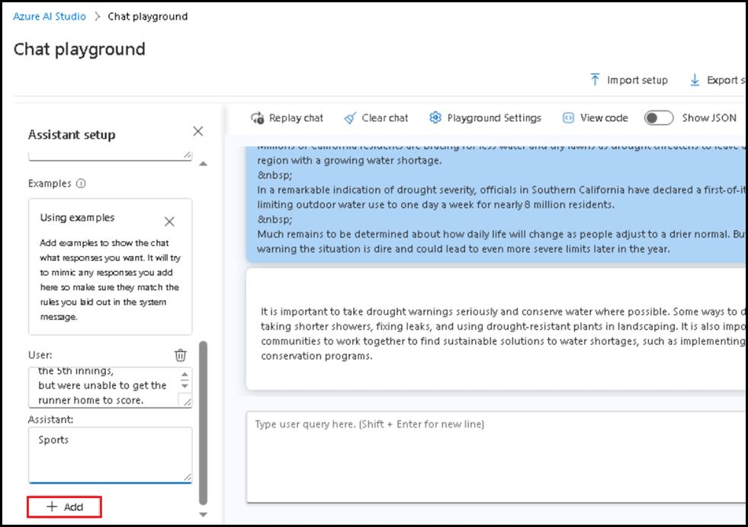

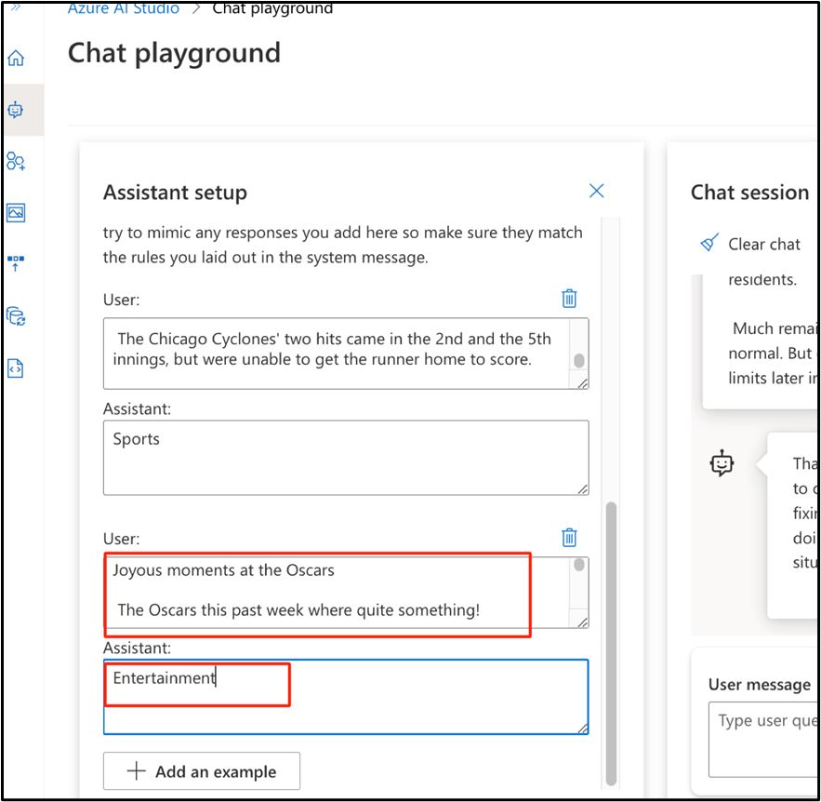

1. Then, click on **Apply changes** to save the changes that you have made to the assistant setup.

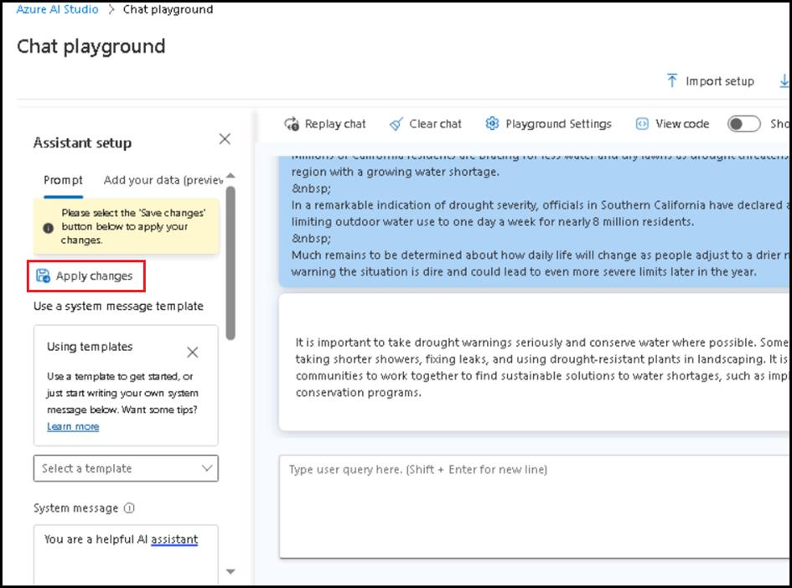

1. In the **Update system message?** dialog box, click on the **Continue** button.



1. Send the same prompt about California drought. In the **User message** text box, enter the following text and click on the **Send** icon.
2. Severe drought likely in California
3. Millions of California residents are bracing for less water and dry lawns as drought threatens to leave a large swath of the region with a growing water shortage.
4. In a remarkable indication of drought severity, officials in Southern California have declared a first-of-its-kind action limiting outdoor water use to one day a week for nearly 8 million residents.

Much remains to be determined about how daily life will change as people adjust to a drier normal. But officials are warning the situation is dire and could lead to even more severe limits later in the year.

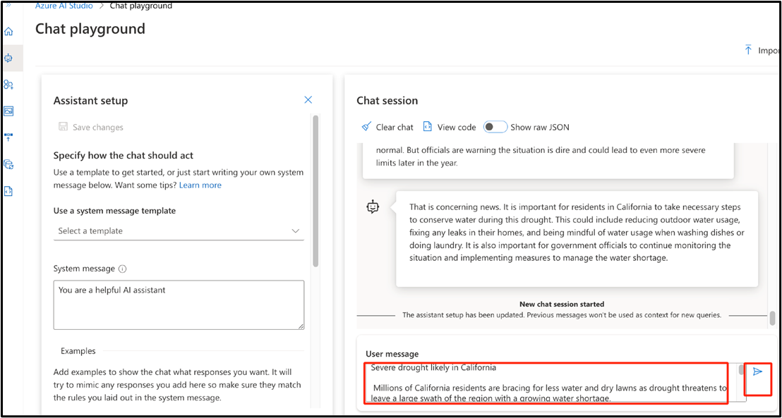

1. This time the model will respond with an appropriate classification, even without instructions.

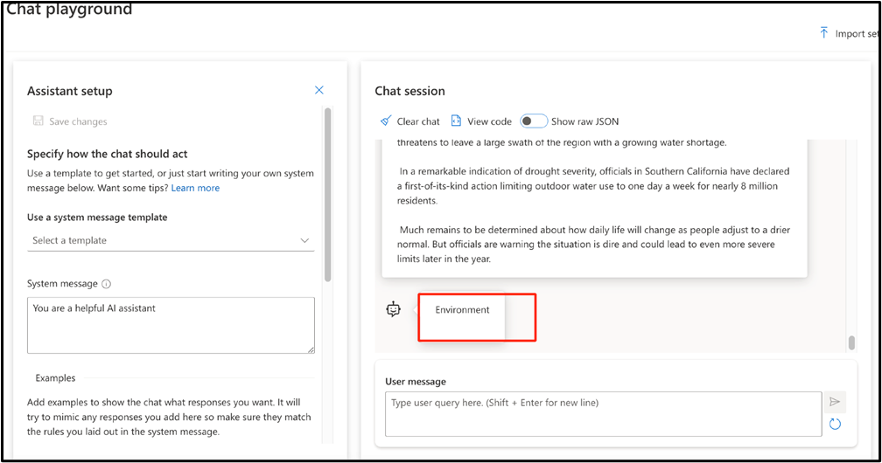

**Task 3: Set up an application in Cloud Shell**

To integrate with an Azure OpenAI model, use a short command-line application that runs in Cloud Shell on Azure.

1. Open a new browser and enter the following URL in the address bar: **https://portal.azure.com/** to open the Azure Portal.

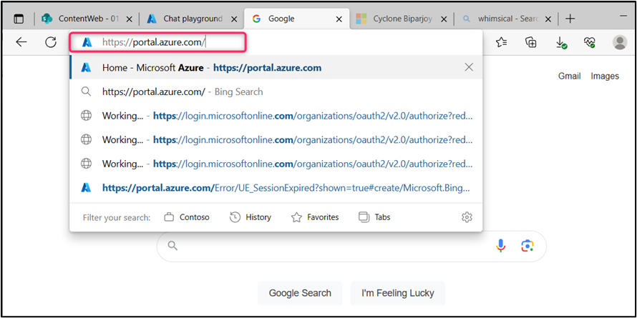

1. In the Azure portal, click on the **[>_] (Cloud Shell)** button at the top of the page to the right of the search box. A Cloud Shell pane will open at the bottom of the portal. The first time you open the Cloud Shell, you may be prompted to choose the type of shell you want to use (**Bash** or **PowerShell**). Select **Bash**. If you don't see this option, then skip this step.

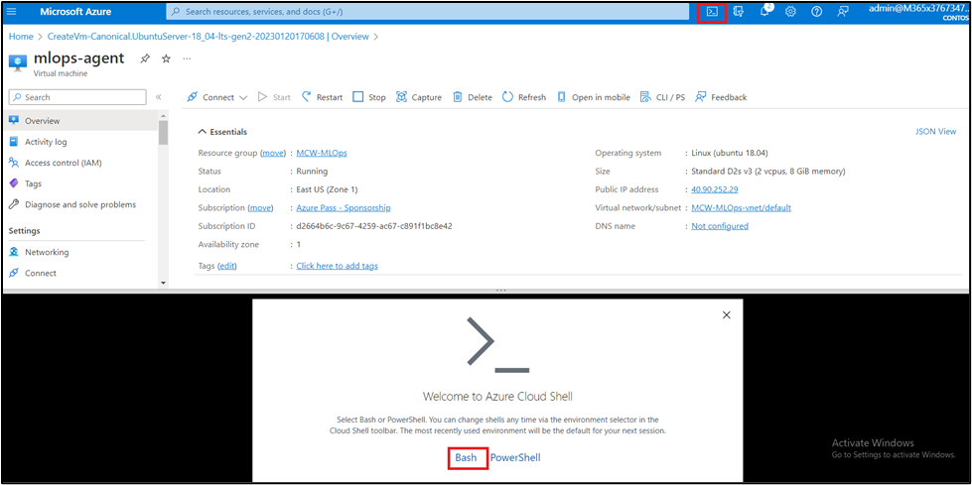

1. In **You have no storage mounted** dialog box, click on the **Create storage**.

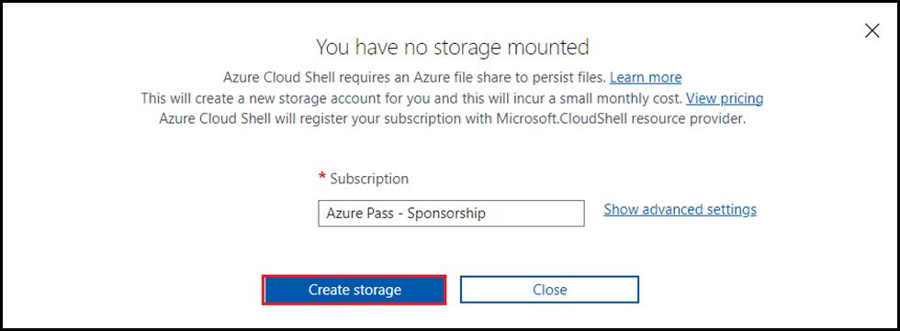

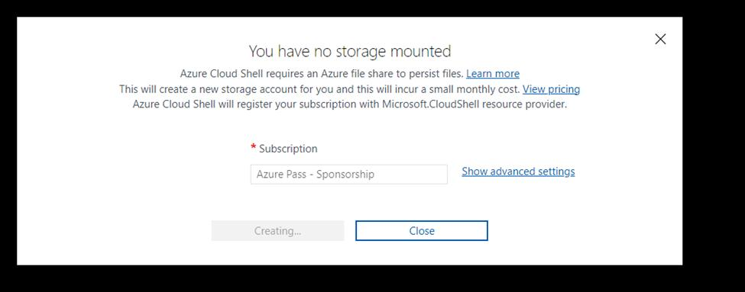

1. Ensure the type of shell indicated on the top left of the Cloud Shell pane is switched to **Bash**. If it's **PowerShell**, switch to **Bash** by using the drop-down menu.

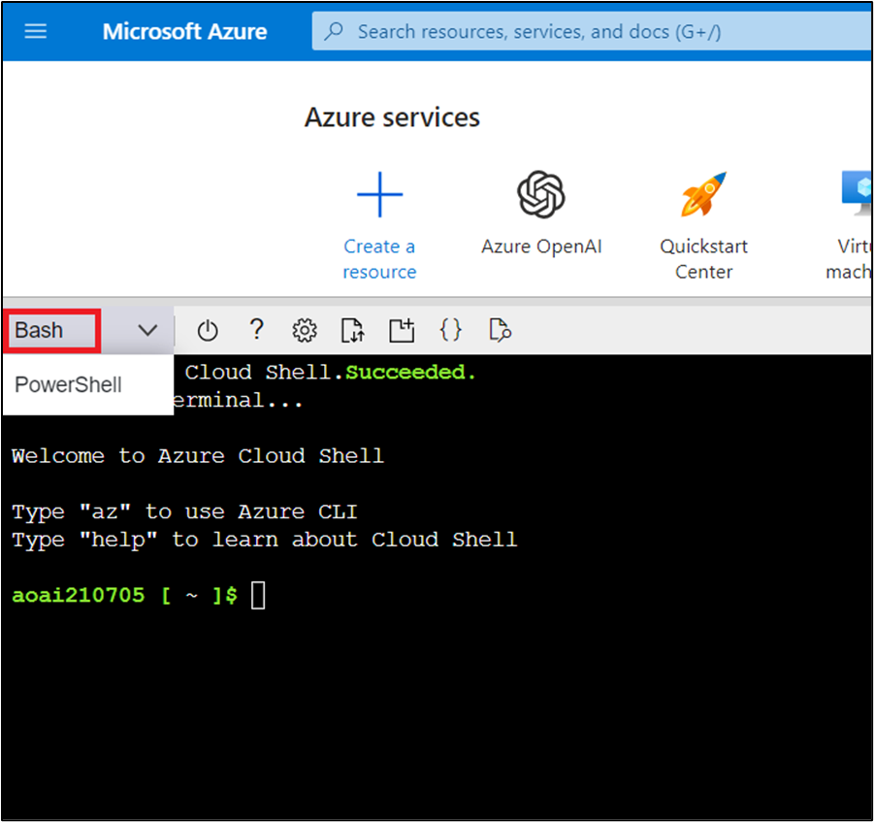

1. Once the terminal starts, enter the following command to download the sample application.

git clone https://github.com/getazureready/mslearn-openai

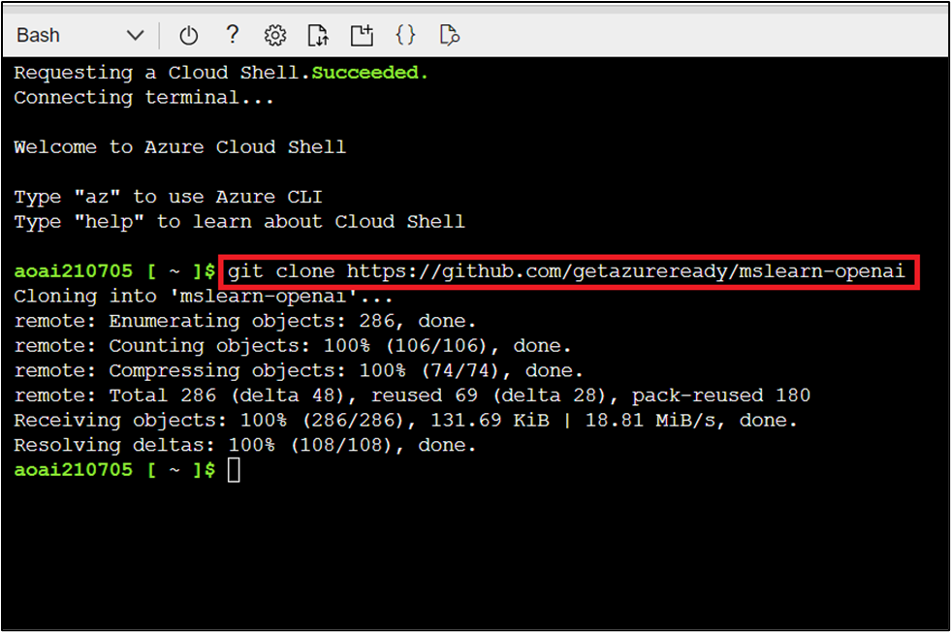

1. The files will be downloaded. Navigate to the lab files for this exercise using the following command.

cd mslearn-openai/Labfiles/03-prompt-engineering

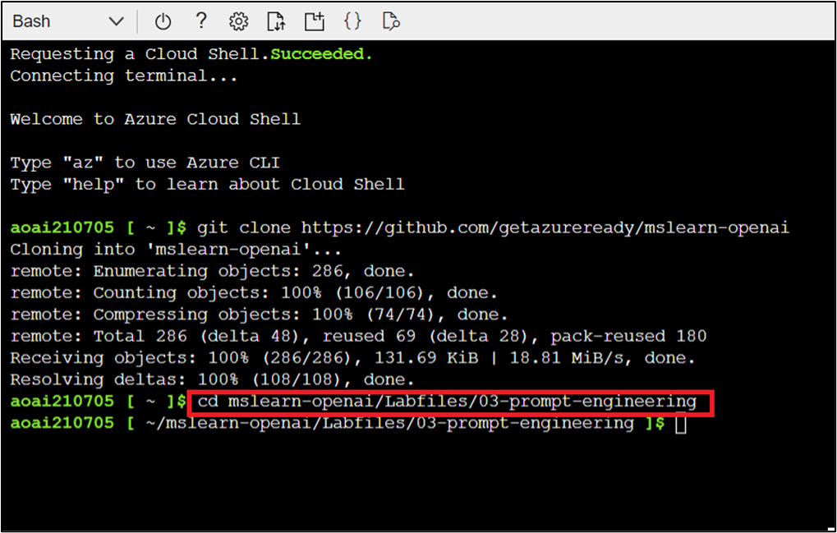

1. Applications for both C# and Python have been provided as well as the text files that provide the prompts. Both apps feature the same functionality.
2. Open the built-in code editor, and you can observe the prompt files that you will be using in **prompts.** Use the following command to open the lab files in the code editor.

code .

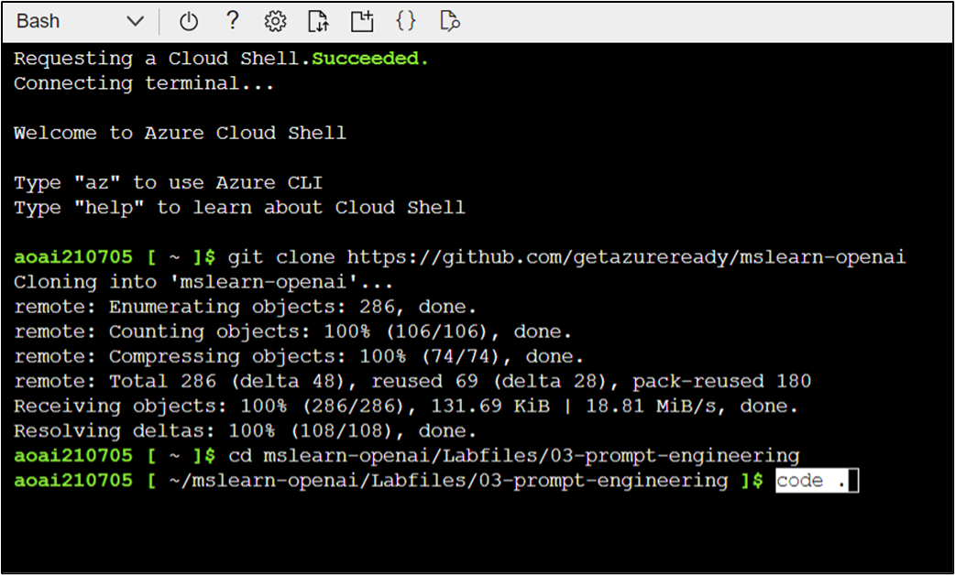

**Task 4: Configure your application**

In this task, you’ll be configuring your application.

1. In the code editor, expand the **Python** folder, click on **.env** file. In the .env file, enter the Azure OpenAI service endpoint and key information. Then, the Azure OpenAI model name that you’ve deployed in Task 1, as shown in the below image.

**Note:** In case, you did not have Keys and Endpoint values, then you can obtain it again by navigating to Azure portal **Home>Resource groups> Assigned Resource Group> Azure OpenAI Service> Keys and Endpoint**. Copy and paste the Keys and Endpoint values on a notepad

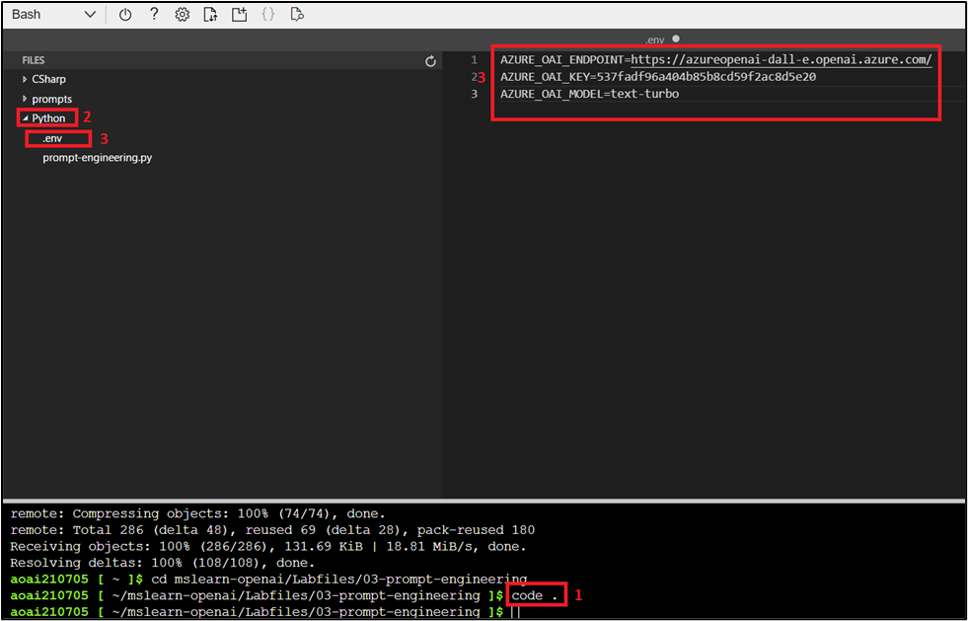

1. Press **Ctrl+S** to save the changes. Then, press **Ctrl+Q** to quit the code editor.
2. Now, install the necessary packages of Python using the following commands.

cd Python

pip install python-dotenv

pip install openai==0.28

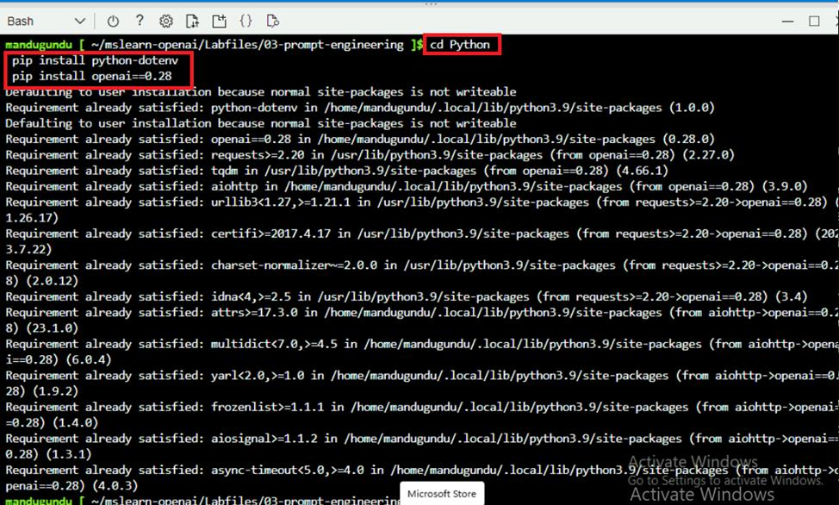

1. Open the lab files in the code editor, then click on **prompt-engineering.py** file and add the necessary libraries. Use the following command to open the lab files in the code editor.

code .

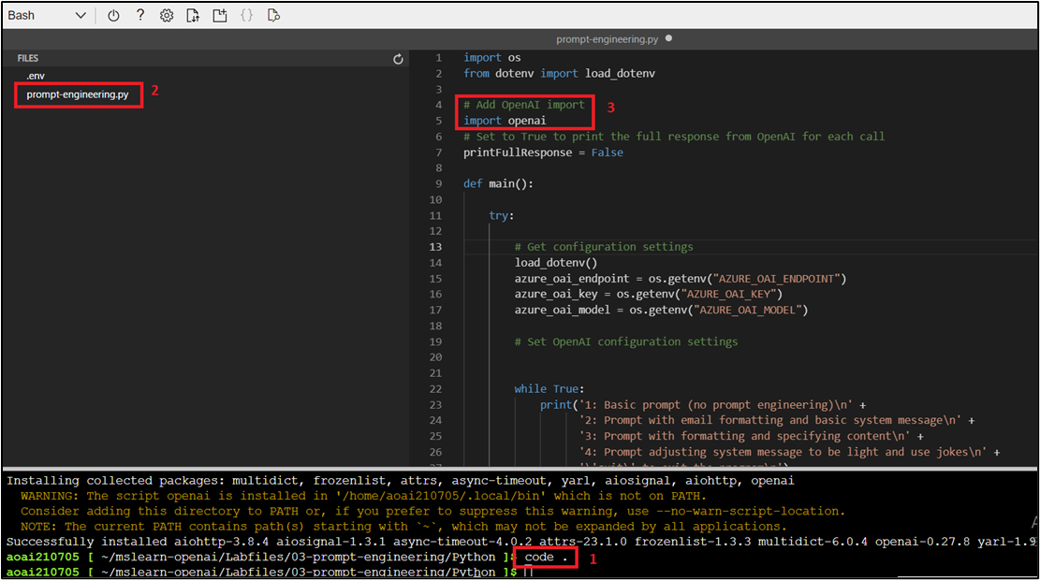

1. In the application code, navigate to **# Add OpenAI import** and add the following code. Press **Ctrl+S** to save the changes.
2. # Add OpenAI import

import openai

1. Then, navigate to **# Set OpenAI configuration settings** and add the following code to configure the client.
2. # Set OpenAI configuration settings
3. openai.api_type = "azure"
4. openai.api_base = azure_oai_endpoint
5. openai.api_version = "2023-03-15-preview"

openai.api_key = azure_oai_key

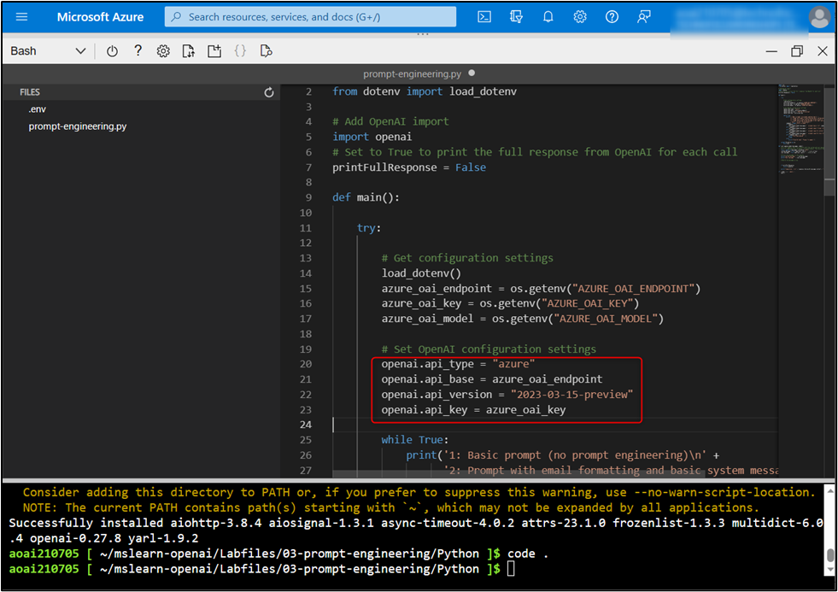

1. In the function that calls the Azure OpenAI model, add the code to format and send the request to the model.
2. # Build the messages array
3. messages = [
4. {"role": "system", "content": system_message},
5. {"role": "user", "content": user_message},
6. ]
7. # Call the Azure OpenAI model
8. response = openai.ChatCompletion.create(
9. engine=model,
10. messages=messages,
11. temperature=0.7,
12. max_tokens=800

)

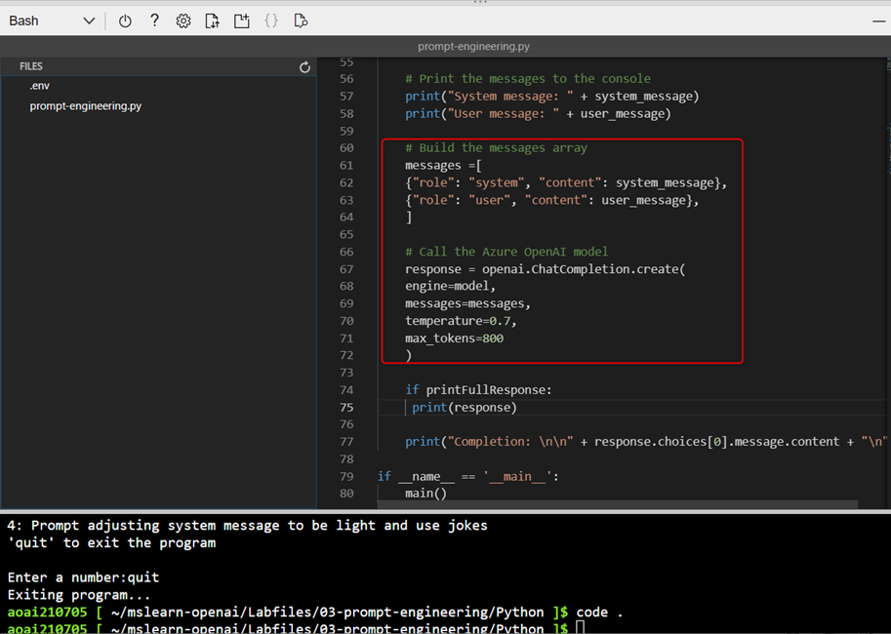

1. Press **Ctrl+S** to save the changes and then press **Ctrl+Q** to quit the code editor.

**Task 5: Run your application**

Now that your app has been configured, run the application to send your request to the deployed model and observe the response. You'll notice the only difference between the different options is the content of the prompt, all other parameters (such as token count and temperature) remain the same for each request.

Each prompt is displayed in the console as it sends for you to see how differences in prompts produce different responses.

1. In the Cloud Shell bash terminal, use the following command and press the Enter button to run the application.

python prompt-engineering.py

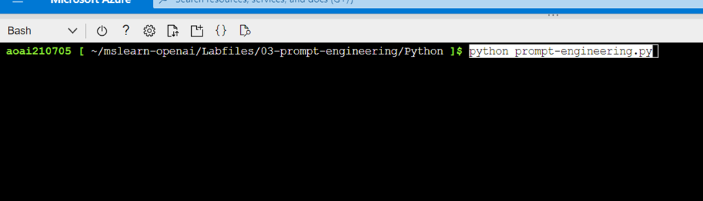

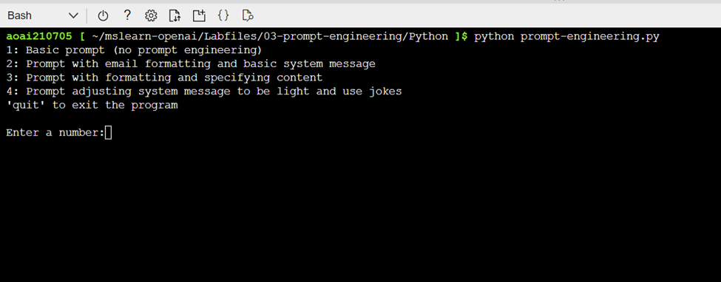

1. Choose option **1** for the most basic prompt.
2. Observe the prompt input, and generated output. The AI model will likely produce a good generic introduction to a wildlife rescue.

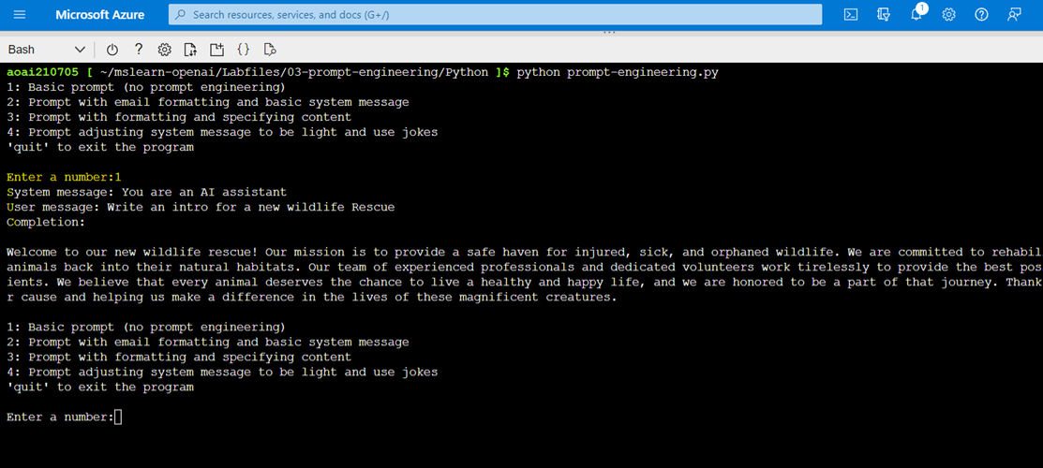

1. Next, choose option **2** to send a prompt asking for an intro email, along with some details about the wildlife rescue.
2. Observe the prompt input, and generated output. This time, you'll likely see the format of an email with the specific animals included, as well as the call for donations.

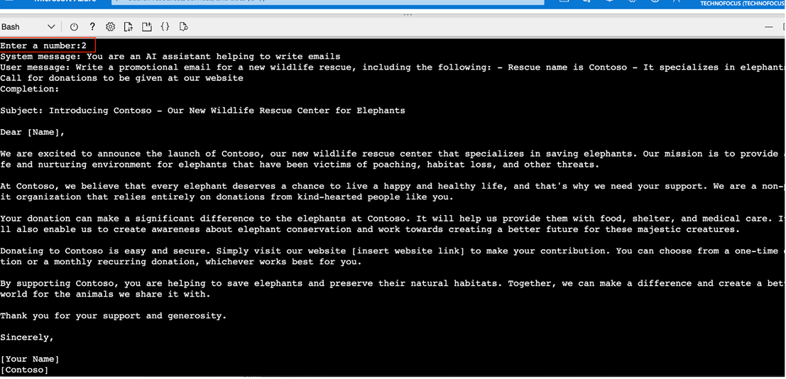

1. Next, choose option **3** to ask for an email similar to above, but with a formatted table with additional animals included.
2. Observe the prompt input, and generated output. This time, you'll likely see a similar email with text formatted in a specific way (in this case, a table near the end) demonstrating how the generative AI models can format output when requested.

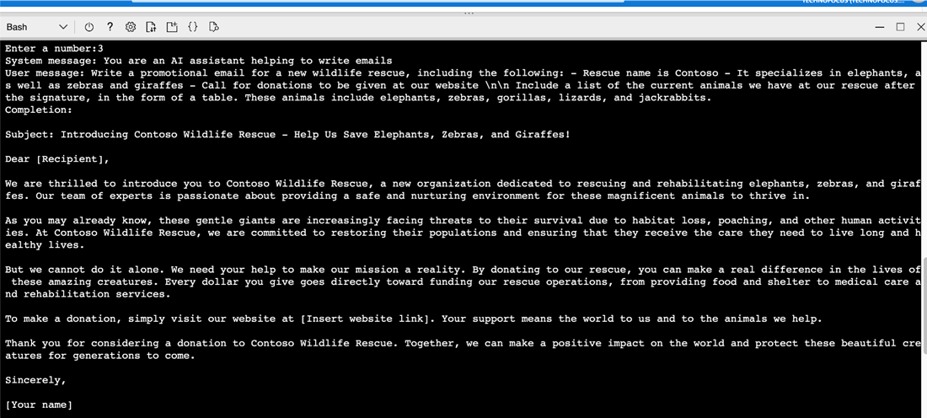

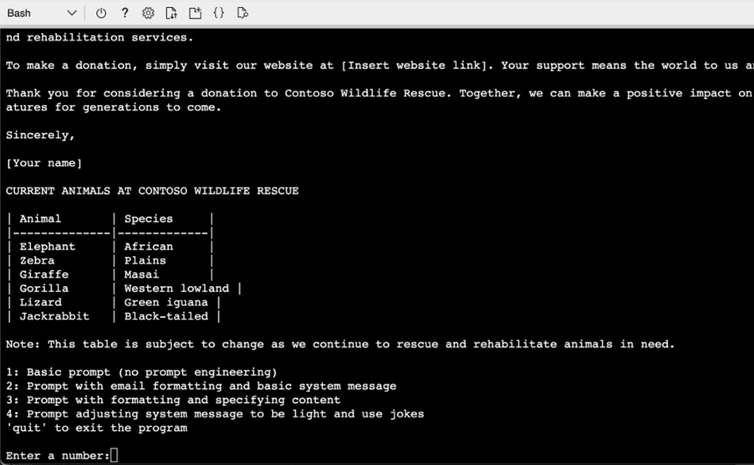

1. Next, choose option **4** to ask for a similar email, but this time specifying different tone in the system message.
2. Observe the prompt input, and generated output. This time you'll likely see the email in a similar format, but with a much less informal tone.

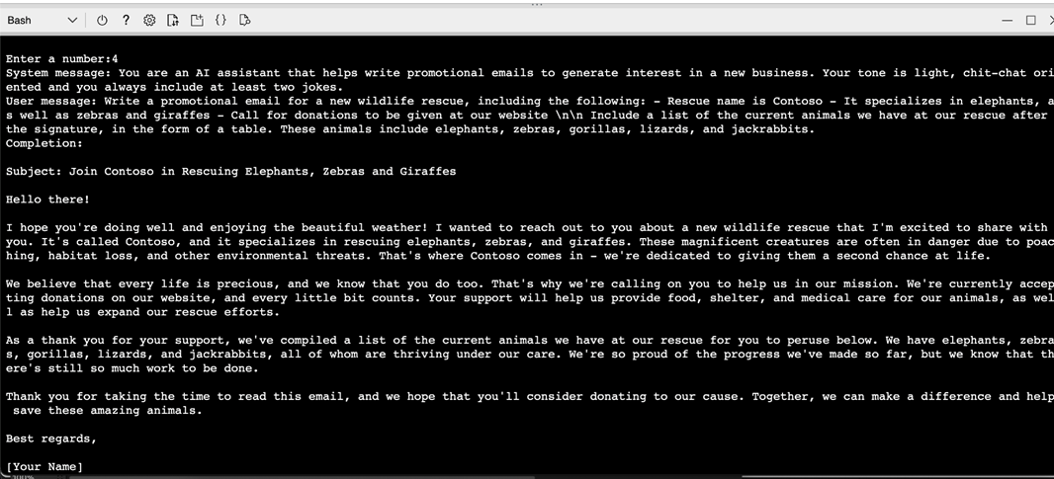

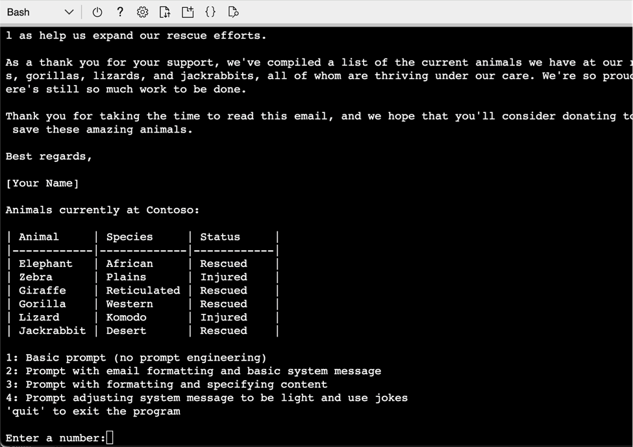

1. Next, choose option **quit** to exit the program.

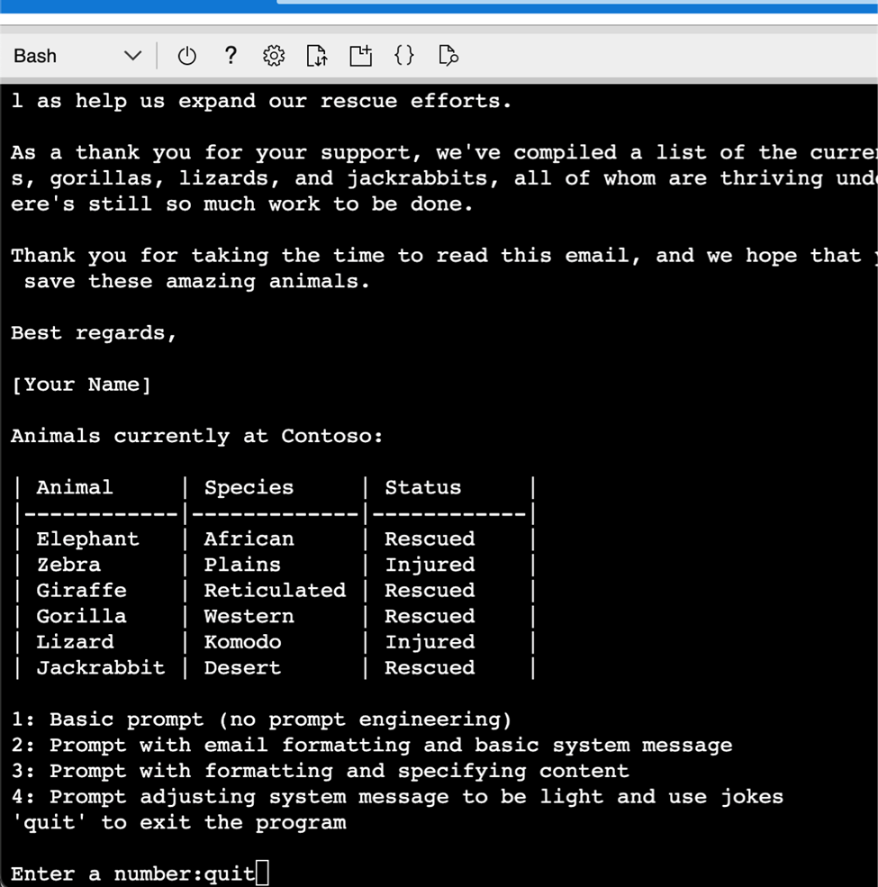

1. Increasing the temperature often causes the response to vary, even when provided the same prompt, due to the increased randomness. You can run it multiple times with different temperature or top_p values to see how that impacts the response to the same prompt.
2. Use the following command to open the lab files in the code editor.

code .

1. To see the full response from Azure OpenAI, set the **printFullResponse** variable to **True** (Line #74) as shown in the image.

if printFullResponse:True

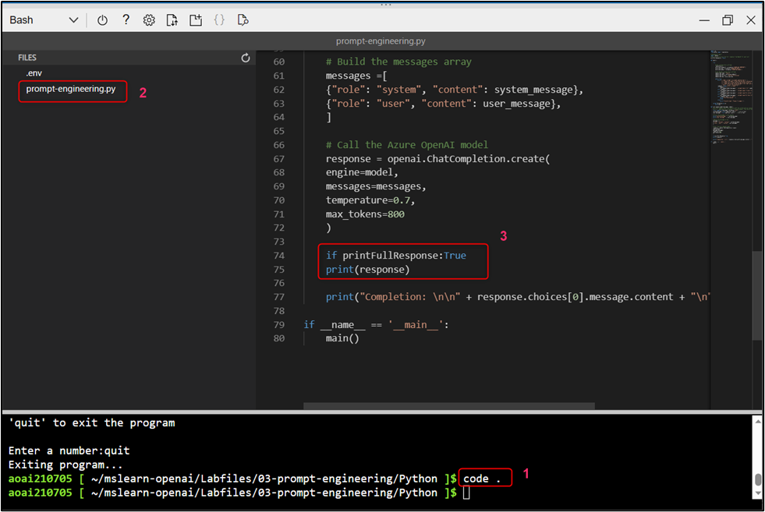

1. Press **Ctrl+S** to save your changes. Then, press **Ctrl+Q** to quit the code.
2. In the Cloud Shell bash terminal, run the application using the following command.

python prompt-engineering.py

1. Choose option **1** for the most basic prompt.
2. Observe the prompt input, and generated output. The AI model will likely produce a good code generic introduction to a wildlife rescue.

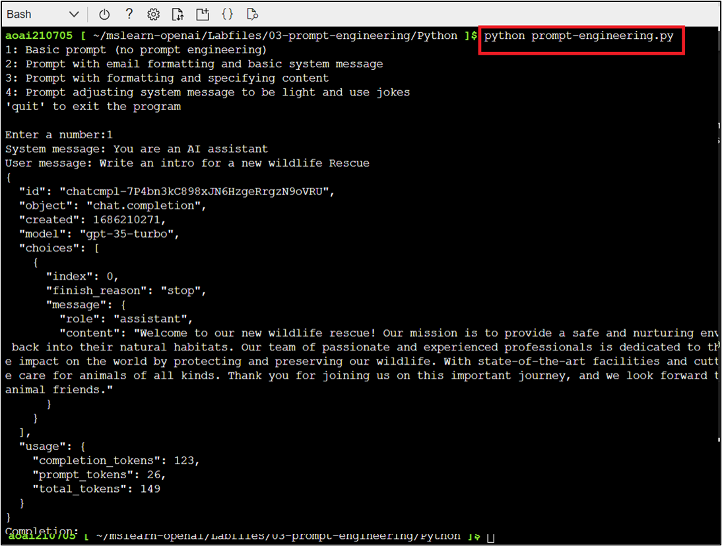

**Note**:

(1). In case, you received an indentation error related to line #75, then remove the space before **print(response)** and adjust the position as shown in step #13 image.

(2). In case, you did not find code generic text, then close the Cloud Shell and open it again by clicking on the **[>_] (Cloud Shell)** button at the top of the page and enter the following commands:

cd mslearn-openai/Labfiles/03-prompt-engineering

cd Python

python prompt-engineering.py

1. Next, choose option **2** to send a prompt asking for an intro email, along with some details about the wildlife rescue.
2. Observe the prompt input, and generated output. This time, you will see the format of an email with code the specific animals included, as well as the call for donations.

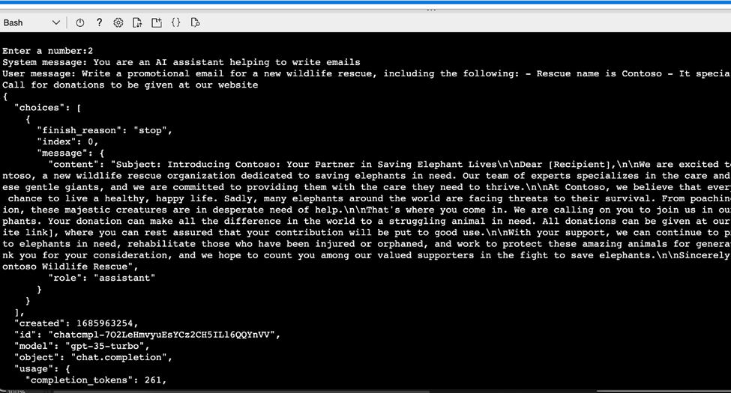

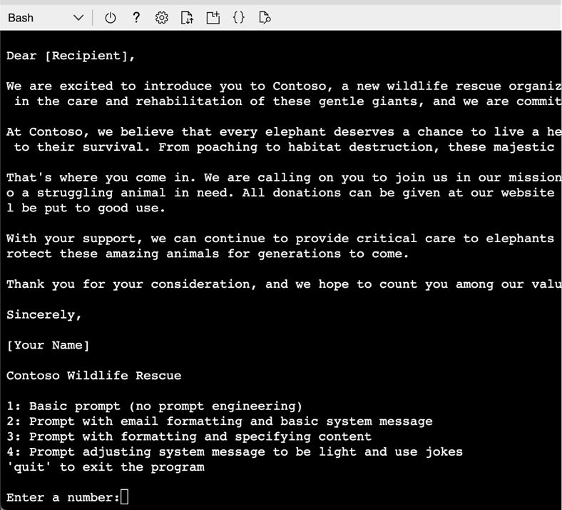

1. Next, choose option **3**, observe the prompt input, and generated output.

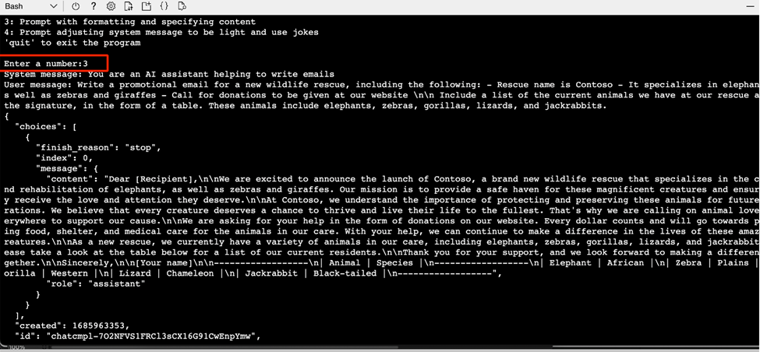

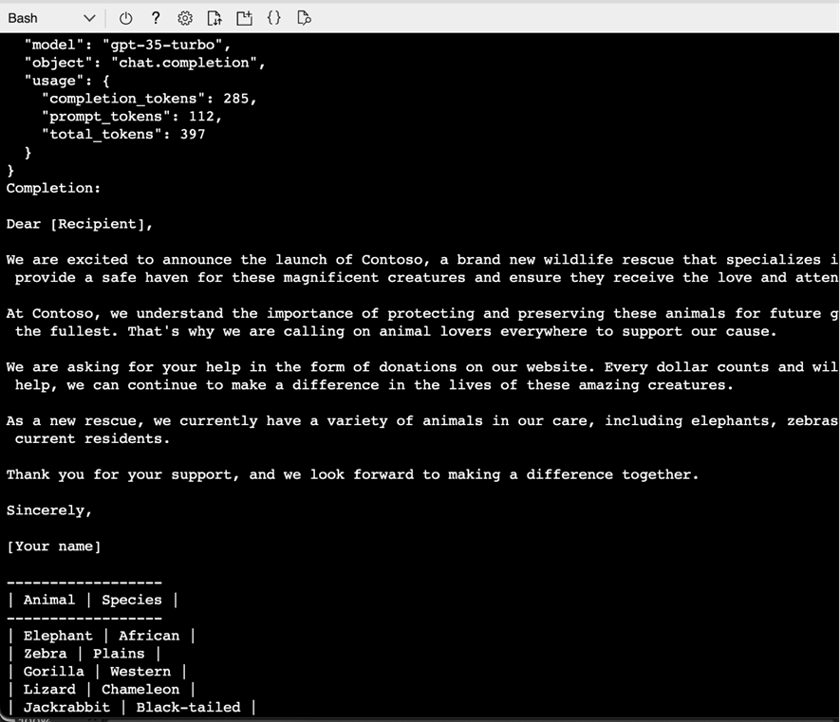

1. Choose option 4, observe the prompt input, and generated output.

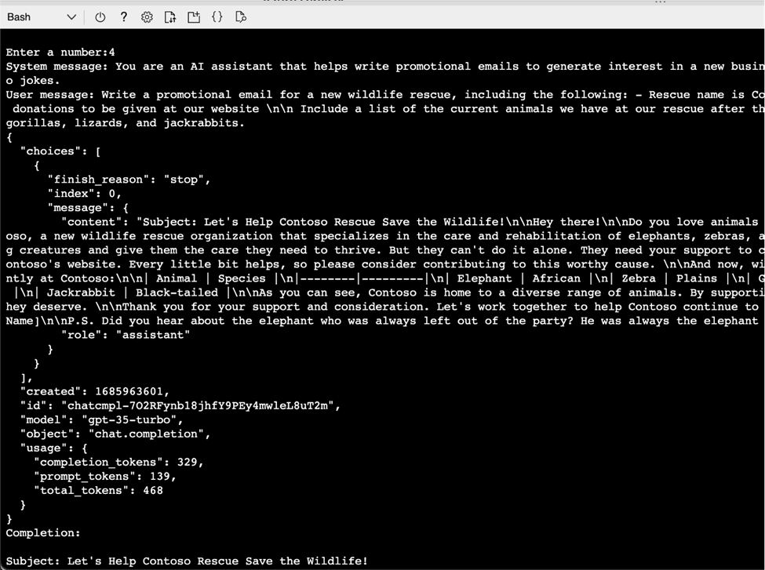

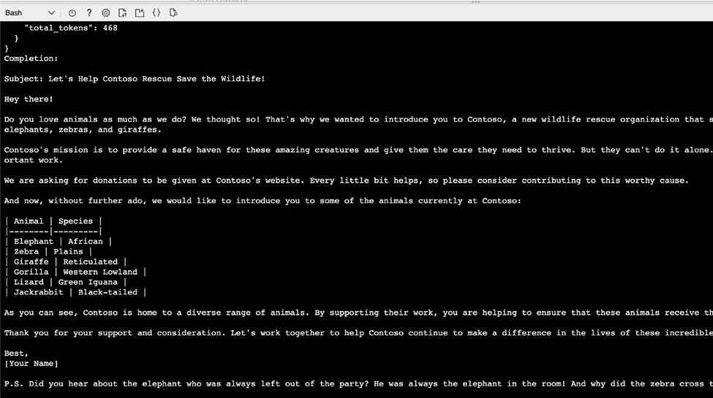

1. Next, enter **quit** to exit the program.

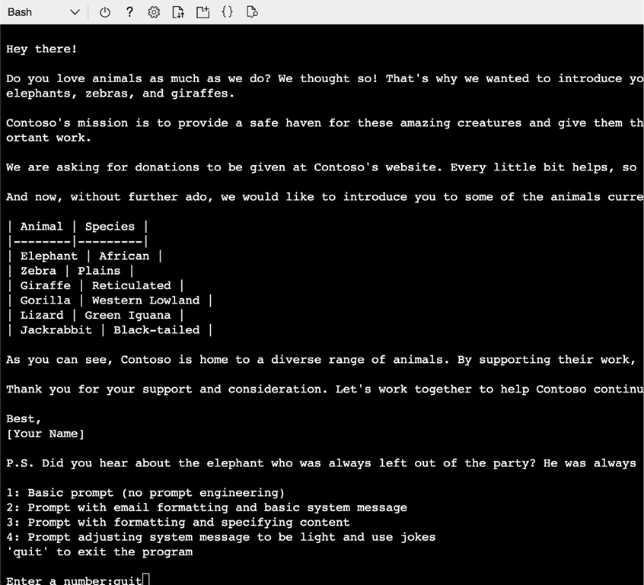

**Task 6: Delete the deployed model and storage account**

1. In Azure OpenAI Studio, on the left pane, under the **Management** section, click on **Deployments**.

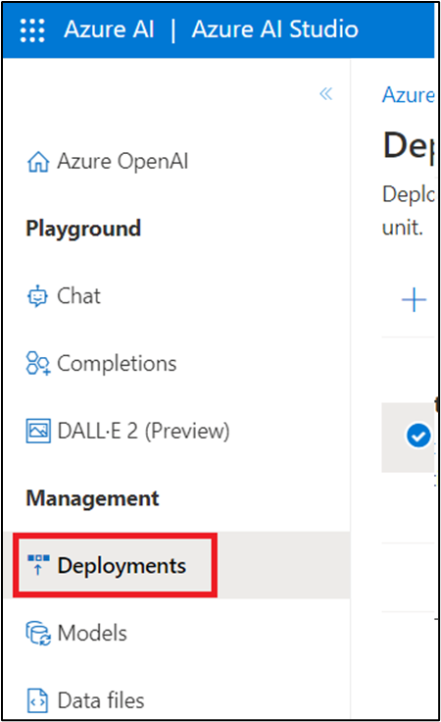

1. Select **text-turbo** deployment name and click on **Delete deployment**.

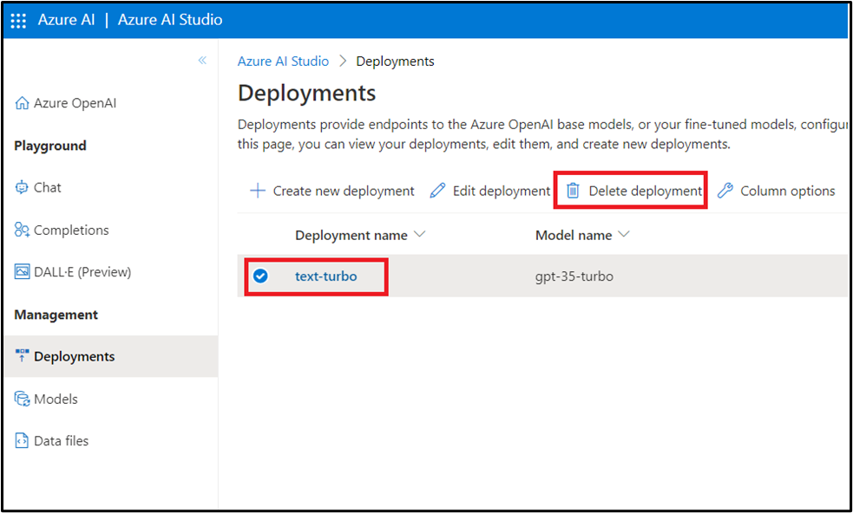

1. In the **Confirm delete** dialog box, click on the **Delete** button. You will see the notification -- **Successfully Deleted deployment** (In case, you did not see the notification, then click on the bell icon beside **Azure AI | Azure AI Studio**).

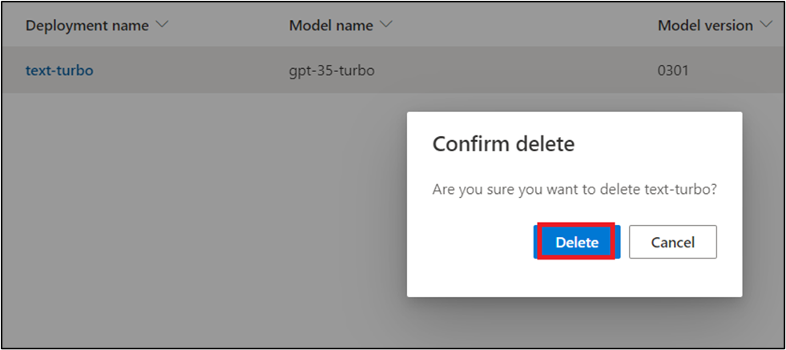

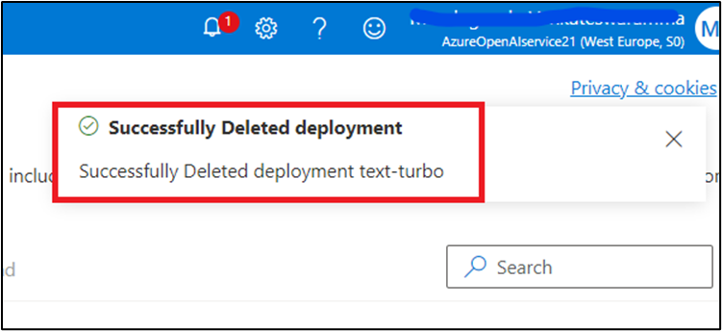

1. To delete the storage account, navigate to **Azure portal Home** page, click on **Resource groups**.

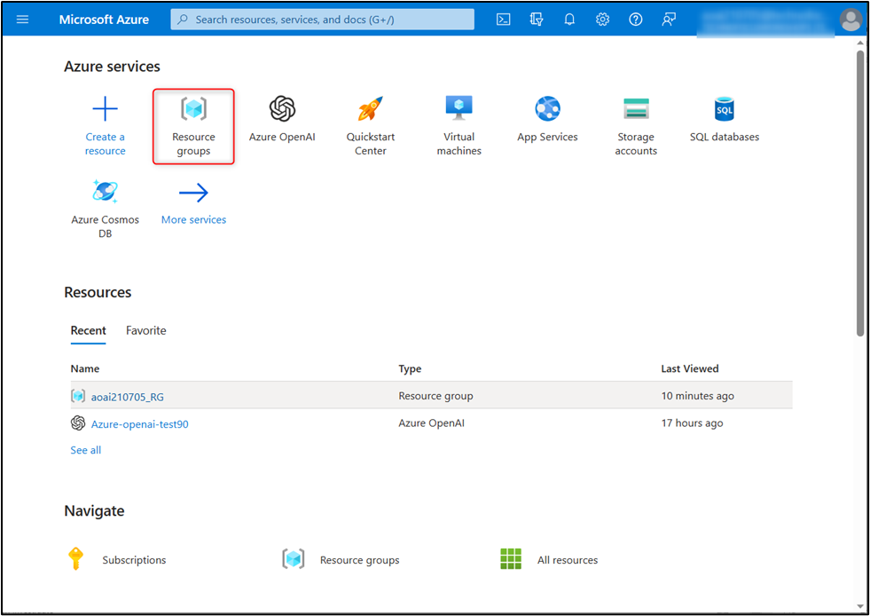

1. Click on the assigned resource group.

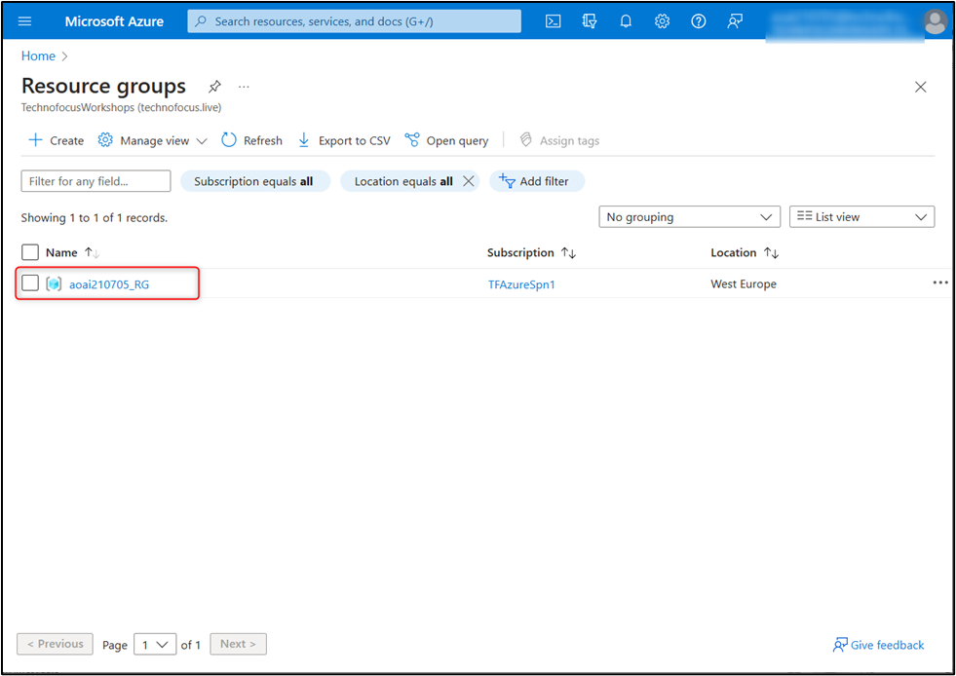

1. Click on the storage account that you've created (here, in this lab, we've created **aoaistorage98**).

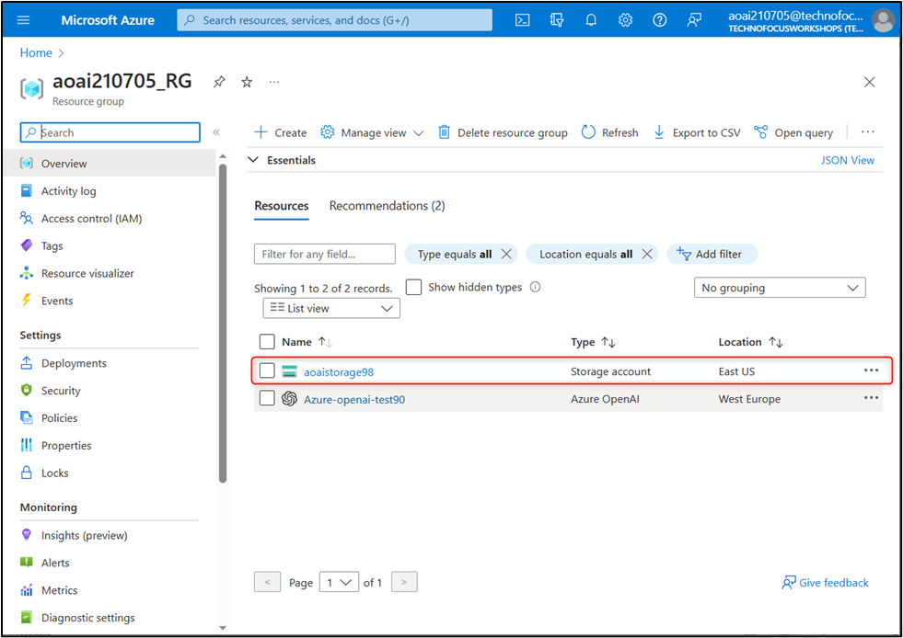

1. In the Storage account page, navigate to command bar and click on **Delete**.

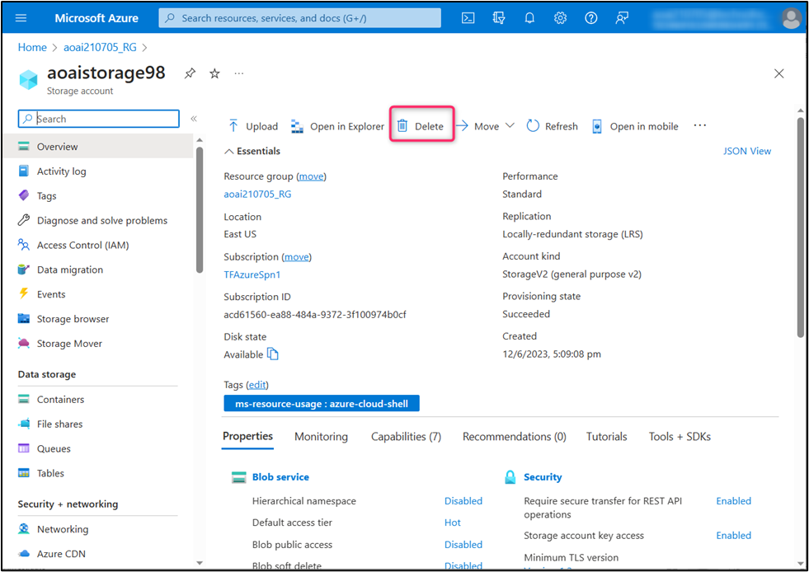

1. In the **Delete storage account** pane that appears on the right side, enter the storage account name and click on **Delete** button.

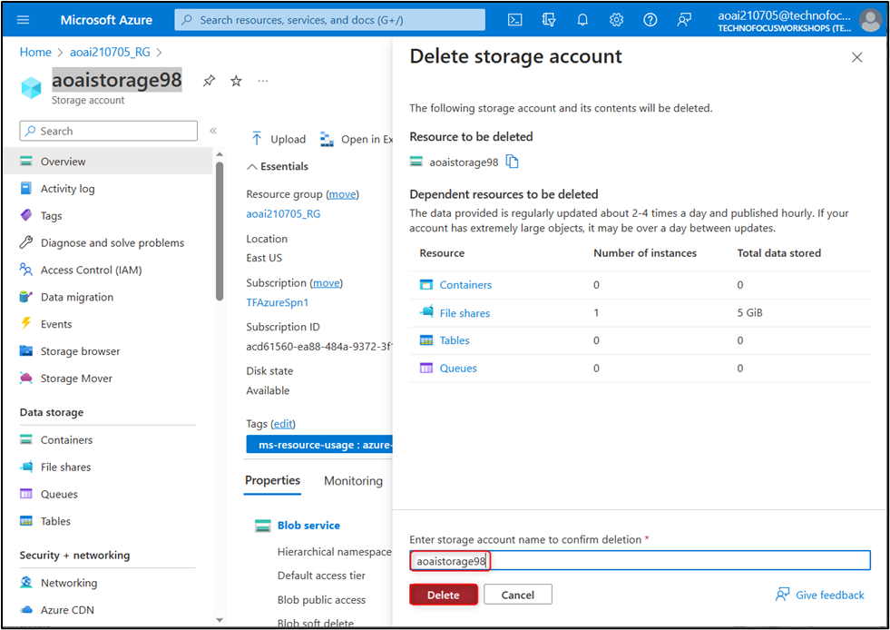

1. On **Delete confirmation** dialog box, click on **Confirm delete** button.

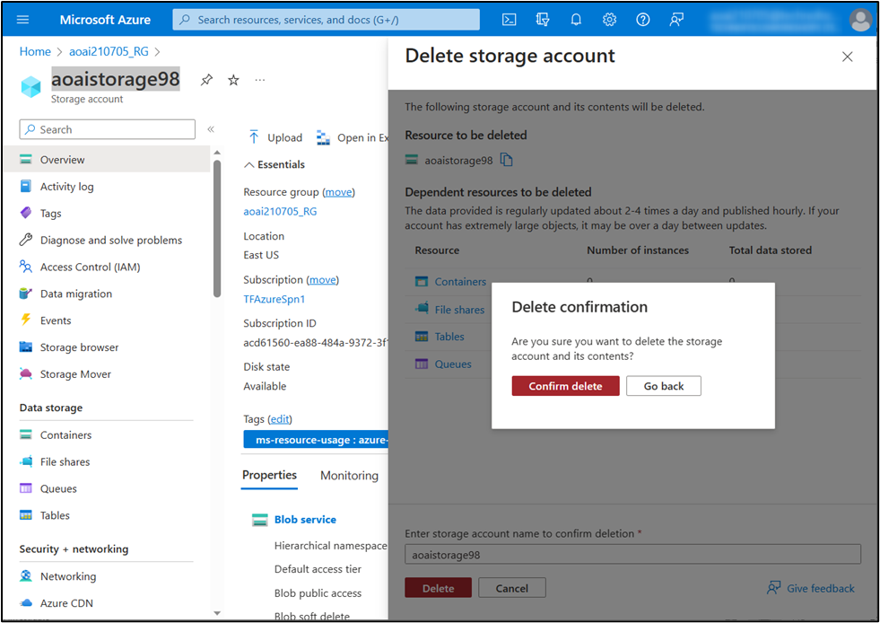

1. Click on the bell icon, you'll see the notification -- **Successfully deleted storage account**.

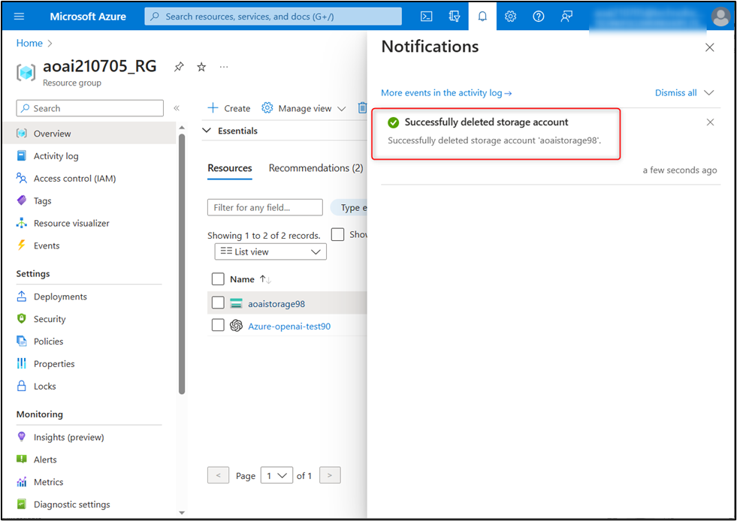

**Summary** In this lab, you've deployed gpt-turbo-35 model in Azure AI Studio, examined how prompt engineering improved the model response in the Chat playground. You've set up, configured, and ran your application in Azure Cloud Shell, then you've sent your request to the gpt-35-turbo model and observed the response. In the last task, you've deleted the deployed model and storage account to efficiently manage your Azure resource.

**Important Note: Please do not delete the Resource group and Azure OpenAI Service (Azure-openai-testXX). The same Resource group and AOAI service will be used throughout all the labs.**